 | Final Capstone Project Report  Spring 2025 | MBAI/MFDA 5600G - Applied Integrative Analytics Capstone Project
Rule-based and Machine Learning Models for Intraday Stock Forecasting
^{Youssef Soliman, Feifan Chen}
Abstract
This study investigates the predictive powers of rule based approaches and machine learning models for intraday stock price forecasting, focusing on Amazon (AMZN) intraday data. The research uses one minute, two minute and multi-frame interval data collected over a year and compares traditional rule based trading strategies, including brute force threshold optimization for technical indicators against machine learning classification models like XGBoost and Artificial Neural Networks (ANN). A complete feature selection process including backtesting and causal discovery via the PCMCI algorithm identified Rate of Change (ROC) and Moving Average Convergence Divergence (MACD) as the most causally significant indicators. The XGBoost and ANN models demonstrated modest predictive power, achieving accuracies of 54.36% and 53.72% in multi-timeframe setups. Both models suffered performance issues once transaction costs were considered. This highlights the challenges of using high frequency strategies in the stock market. The results show the importance of feature selection and transaction cost sensitivity especially in high volume trading environments

Keywords: Intraday trading; Technical analysis; Feature selection; Multi-timeframe modeling

Introduction
The stock markets are very complex with many micro and macro factors affecting it which causes trends and rapid fluctuations in stock prices. In intraday trading, decisions must be made within seconds in order to maximize the return. Traditionally traders rely on strategies that mix technical indicators with personal experiences to determine entry and exit strategies. These methods can sometimes be effective but they are vulnerable to human emotions and cognitive biases.

This paper examines different strategies using machine learning and deep learning to predict directional stock movement in intraday Amazon stock data. Specifically, the paper examines two different methodologies for predicting directional movement of intraday stock price movements: rule based models and machine learning classification models. The rule based approach aims to find optimal trading thresholds for individual technical indicators through exhaustive brute force searches, working as a baseline for comparison. For machine learning the paper uses the XGboost and artificial neural networks (ANN) to learn from historical data and attempt to find nonlinear relationships among features to predict the future direction of stock prices.

Our primary dataset consists of one year of 1 minute intraday stock data for Amazon (AMZN) from May 2024 till May 2025, with an equivalent dataset from Meta (META), Microsoft (MSFT) and Nvidia (NVDA) used to evaluate the model. We explore and evaluate the predictive power of over 30 commonly used technical indicators, apply multiple feature selection techniques, including sequential forward selection, random forest importance, and causal discovery via PCMCI and assess how well the selected features perform.

This research aims to bridge the gap between traditional indicator based trading and data driven predictive modeling by offering insights into the strengths and limitations of each approach in the context of intraday trading.

Literature Review:
In the last decade there has been a major spike in machine learning advancements and popularity, which has led to the creation of machine learning models attempting to predict the direction of stocks in the stock market. Papers have used different approaches to predict the stock market using hybrid deep learning models like LSTM and CNN. As one study found, deep learning models, especially LSTMs and transformers, outperform traditional methods "by capturing complex, nonlinear patterns in the data", resulting in more accurate predictions (Zhang et al.)[6]. Another study found that "the model consisting of only two GRU layers and the XGBoost model showed the best overall performance compared to the other models tested as evidenced by the low average values of MAE, MSE, RMSE, MAPE, and R2 across all folds." (Teixeira, 2025)[7] The GRU combined with the XGBoost model outperformed deep learning models like the RNNs and CNNs.

Several other studies have focused on using deep learning models to predict stock market movements.

A comparative study of deep neural networks (DNN) and long short-term memory (LSTM) investigates the two models’ performance among daily and bi-weekly stock forecasting in the Indian stock market (BSE Sensex). (Shah et al., 2018) [21]. The study claims both machine learning models output robust results in daily stock forecasting with similar model accuracy and low error rates. However, LSTM outperforms in bi-weekly forecasting, reflected in better volatility handling and capture of directional change. The limitation of DNN in the bi-weekly tasks is concluded as its lack of a 'memory' function, which is crucial for longer term forecasting in time series.

The study by Shen et al. (2020)[22] compares multi-layer perceptrons (MLPs), support vector machines (SVMs), random forest classifier (RF), Naïve Bayes classifier (NB), logistic regression classifier (LR) and long short-term memory networks (LSTMs) with PCA techniques. The LSTM model has the highest binary accuracy for bi-weekly stock price prediction for all the models because of the benefit of decreased overfitting through the process of feature selection.

Some studies found out that choosing the right time period of past data can affect how well the model predicts future prices. Shynkevich et al. (2017)[2] found that the model gave more accurate predictions when the input window was similar to the forecast horizon (how far ahead it was trying to predict). This means that choosing the right time period for the input data is very important when building stock prediction models. "The highest prediction performance is observed when the input window length is approximately equal to the forecast horizon."

Other studies have focused on the performance of XGBoost and other tree based models in predicting stock prices.

In their 2025 study, Mostafavi and Hooman (2025)[15] used XGBoost with technical indicators, among other machine learning algorithms, to predict daily S&P 500 prices. For XGBoost, Ichimoku Cloud and HWMA were identified as important indicators with and without lag. However, the XGBoost model had poor performance when compared to the other models.

Hossain and Kaur (2024)[17] paper disagrees with Mostavfi (2025) as it highlights the strengths of XGBoost in tabular data processing. In the paper Hossain states that XGBoost frequently performs well in capturing complex relationships within data.

Gumelar et al. (2020)[18] suggested the using an XGBoost model as the model showed amazing performance with a 99% prediction accuracy in predicting close stock prices for companies on the Indonesia Stock Exchange (IDX). Another study by Tong et al. (2023)[19] made across different industries (technology, healthcare and others) showed that XGBoost generally had strong performance with lower Mean Squared Error (MSE) and Mean Absolute Error (MAE) values compared to standalone ARIMA and LSTM models.

Some studies look at how well artificial neural networks (ANNs) and their combined versions work for predicting stock prices.

Ayyildiz and Iskenderoglu (2024)[14] compared different machine learning algorithms to predict stock market index movement directions in developed countries. Their analysis of G-7 major stock market indices revealed that Artificial Neural Networks (ANNs) showed the highest average prediction performance.

Strader et al. (2019)[16] conducted a literature review to identify directions for future machine learning stock market prediction research by evaluating existing studies from the past twenty years. Their findings agree with Ayyildiz and Iskenderoglu (2024) that ANNs are best for predicting numerical stock market index values when compared to other deep learning and machine learning models.

Zhong et al. (2019)[9] evaluates artificial neural networks (ANN) and deep neural networks (DNN) in forecasting the direction of daily return on SPDR S&P 500 ETF (SPY), using 60 economic and financial features. ANN and DNN are applied to the unprocessed dataset, along with transformed data with principal component analysis (PCA), which has been found to be one of the most effective feature reduction methods in Zong and Enke’s previous studies. The simulation results reflect that the hybrid models of ANN/DNN and PCA give higher classification overall accuracy than the untransformed data.

Another study proposed a hybrid model using Piecewise Linear Representation (PLR) and ANNs to explore the non linear relationship between stock close price and technical indicators (Chang et al., 2011)[10]. PLR aims to find the optimal turning point (trading signal) from the historical stock index and is used for ANN training. ANNs model makes predictions on further signals and on a daily basis. The buy or sell actions are determined if the prediction is above or below the dynamic thresholds. The experiment results demonstrate such hybrid models achieve a higher return rate (e.g., 61.28% for Apple) than a random walk strategy (8.02%).

Qiu et al. (2016)[23] focuses on predicting the direction of stock index by applying ANNs combined with a genetic algorithm (GA) on the Japanese Nikkei 225. The study showed that ANNs can find patterns in stock data, even though the underlying mechanisms are not entirely understood. . The study found that the model's performance depends a lot on which input features are used. GA is applied to optimize the weights of ANN before the training process. Two sets of technical indicators are compared: one set of broad selection (type1), and another set of careful selection (type2). Type2 provides an 81.2% hit ratio whereas type1 only has 60.87% which proves the importance of both feature selection and optimization to get high accuracy in ANN models for stock forecasting.

Feature selection and dimensionality reduction are also identified as critical components influencing model performance. Both Basak et al. and Ji et al. emphasize the importance of feature selection. Both papers show the improvement in their models when selecting appropriate features. Basak et al. (2019)[4] show the importance of feature selection saying the "flexibility with the use of various features, each with its own interpretation has been useful." The feature selection process allowed for better results, improving recall and precision in almost all models used. In Ji et al. (2022)[5], they find that the two-stage adaptive feature selection approach used in the paper achieved an accuracy of 0.937 for stock direction predictions across four global indices. This represented a 12% improvement in both accuracy and F1-score compared to using raw technical indicators.

The comprehensive survey conducted by Htun et al. (2023)[20] reviews 32 studies from 2011 to 2022 talking about feature selection and feature extraction techniques as the accuracy of stock prediction is very dependent on the indicators. Htun categorizes feature selection into four main types: filter, embedded, wrapper, and information theory-based methods. Widely used techniques that have proven to produce high accuracy in machine learning model predictions include correlation based criteria, random forest, PCA, and autoencoder.The paper refers the concept of the ‘curse of dimensionality’ which means that a large number of features can increase the model’s run time and potentially produce worse accuracy results which suggests that more features do not necessarily lead to better performance.

Finally, some researchers argue that a model’s accuracy does not always translate to real world profitability.Research by Nguyen et al. (2024)[3] discusses the idea that high forecasting accuracy does not necessarily mean higher profitability in stock trading. The authors find that "the accuracy of a predictive model does not exhibit a linear correlation with profitability. Despite many studies emphasizing high accuracy as a performance metric, it does not guarantee profitability in real-world trading scenarios." They argue that papers should change from performance metrics to actual returns because models optimized for classification accuracy may underperform in practice

Project Workflow:
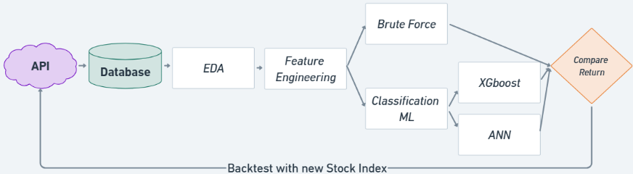
Fig.1. Workflow chart

Fig.1 demonstrates the overview of the project workflow. The process starts with collecting stock data from the Alpha Vantage API with the designated time span and interval. Once data is acquired, datasets undergo exploratory data analysis to gain an insight into the traits of each stock index, such as trend behaviors and historical highs and lows. False signals are then defined and removed to improve the models’ performance. Multiple feature selection methods are applied to identify the technical indicators which are most likely to facilitate the model learning. Features are then fed to the baseline model (Brute Force) and two advanced models (XGBoost and ANN) to testify their predictive capability. The best model is applied to the additional stock indices and tests its consistency and robustness.

Data Description and EDA:

For the dataset, Alpha Vantage API was used as it gave the most consistent and accurate data points. The data gathered was intraday data for Amazon stock (AMZN) from May 2024 till May 2025. The unaltered dataset had pre-market hours and after hours data but for this paper the data was cut down to only US regular market hours (9:30-16:00). This reduced the data size from around 240K data points to around 100K which made the models more efficient. The data had the standard OHLCV (Open, High, Low, Close, Volume).

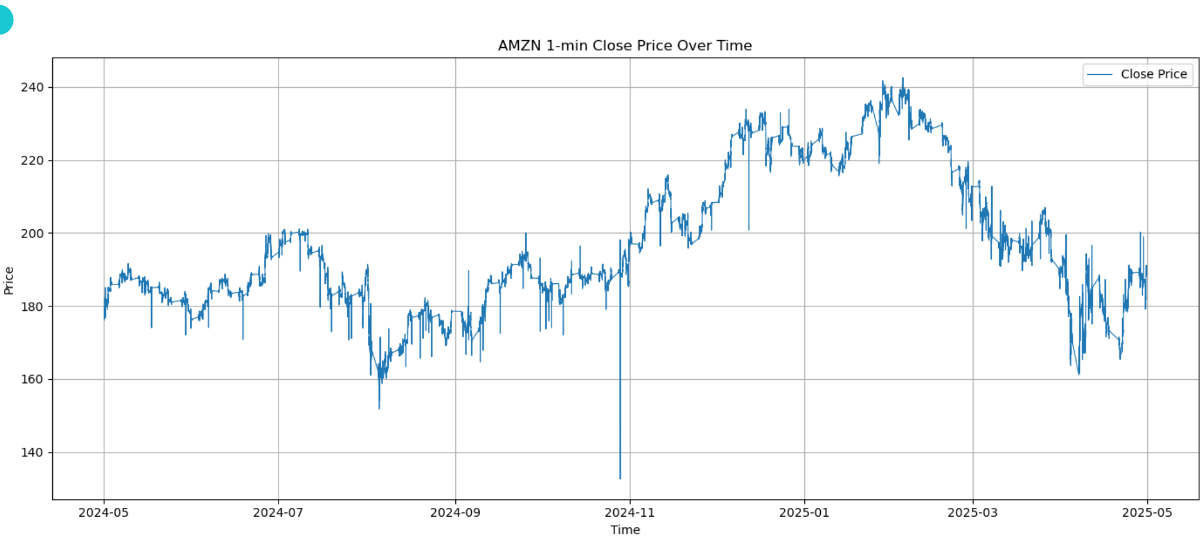
Fig.2: AMZN Stock Price Over One Year (2024–2025)

Upon inspections, the data had a lot of false signals as seen in figure 2 which could affect the model during backtesting. These false signals which are often caused by noise or illiquid trading periods can lead to overfitting and misleading performance metrics. Accordingly, a filtering process was implemented in which the rolling median was applied to smooth out the anomalies as seen in figure 3. If any data point deviated by more than 2% positively or negatively from the rolling median, it was considered a false signal and replaced with the rolling median value. Upon doing so, the price graph seemed more consistent to reality.

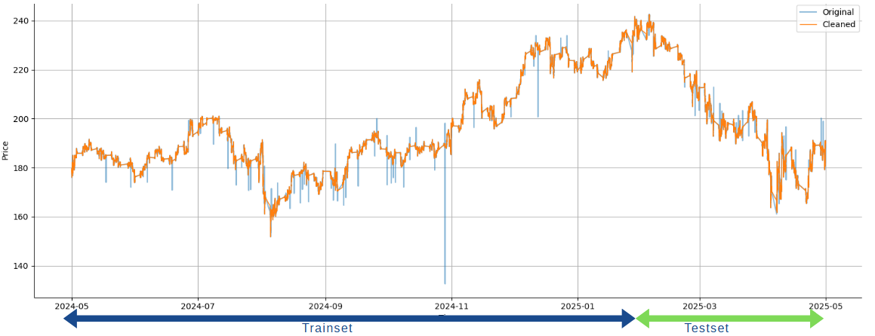
Fig.3: AMZN Stock Price After Applying Rolling Median Filter

4.1. Feature Selection:
The features were chosen based on the 30 most used indicators for intraday trading from the paper by Groette (2025)[13] . The first approach was trying a Sequential Feature Selection method with a regression estimator, the model struggled due to how noisy and complex the data is. To evaluate the predictive strength of each indicator, regressions were conducted across all 30 features. While the mean squared error (MSE) and mean absolute error (MAE) values appeared numerically small, it was an expected outcome given the low variance of intraday financial data. The selected features showed negative or near zero R squared values, indicating no explanatory power. This suggests that none of the indicators alone could explain the meaningful variance in the close price of Amazon. Indicators like MACD_diff had the only slightly positive R squared (0.000160), while others like ROC_12 and PPO had more negative R Squared values which proves that each indicator alone is not good enough to explain the price change.

The second approach attempted was a tree based approach. The Random Forest Classifier was used. Initially, model performance declined when 2–3 features were combined, likely due to multicollinearity or the introduction of redundant signals. However, as more features were added, accuracy improved gradually as seen in figure 4. This trend reversed once the model had more than 10 features, at which point performance began to deteriorate which was proof of overfitting and the increasing influence of noise. These findings highlight the importance of careful feature selection and dimensionality control when working with high frequency financial data.
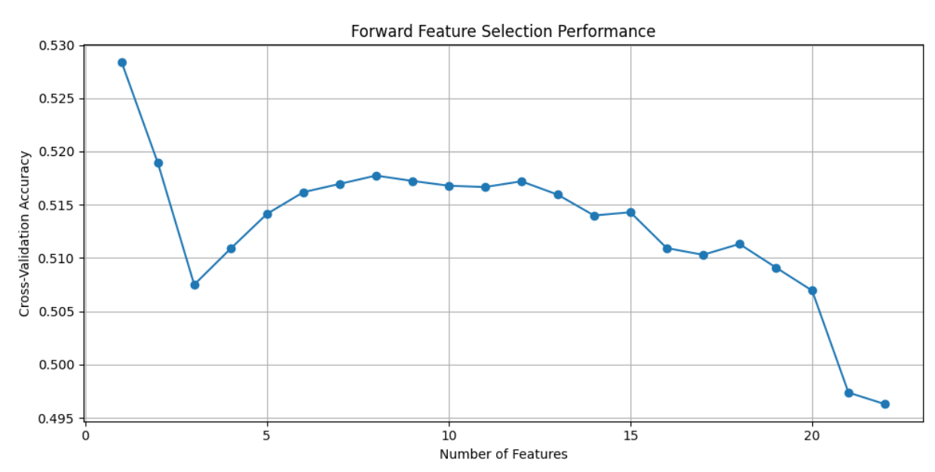
Fig.4: Model Accuracy During Forward Feature Selection

The final model implemented in this study was the causal inference model PCMCI (Peter and Clark Momentary Conditional Independence). The algorithm was designed for time series data. This model was employed to evaluate the causal relationships between the set of 30 technical indicators and the target variable (the intraday ‘Close’ price return) while considering multiple lagged versions of each feature.

A very important step involved was making sure that all features satisfied the stationarity assumption required. This was verified using the Augmented Dickey-Fuller (ADF) test. Variables failing to reject the null hypothesis (meaning that they were non stationary) were transformed via differencing until stationarity was achieved. To minimize multicollinearity and improve model interpretability, we computed both pairwise Pearson correlations and Partial Correlations (ParCorr) amongst the features. Pearson correlation identifies linear correlations while partial correlation isolates the direct linear relationship between a pair of variables, controlling for the influence of all other variables in the dataset. Features that had a correlation above 0.9 were removed from the model to make sure that the results are not inflated due to redundancy. The PCMCI framework was then applied to assess both contemporaneous and lagged causal relationships between the technical indicators and the target. As Runge et al. (2019)[24] stated, “Our method alleviates this problem by a condition selection stage to remove irrelevant variables and a conditional independence test designed for highly interdependent time series,” showing its effectiveness in high frequency settings.

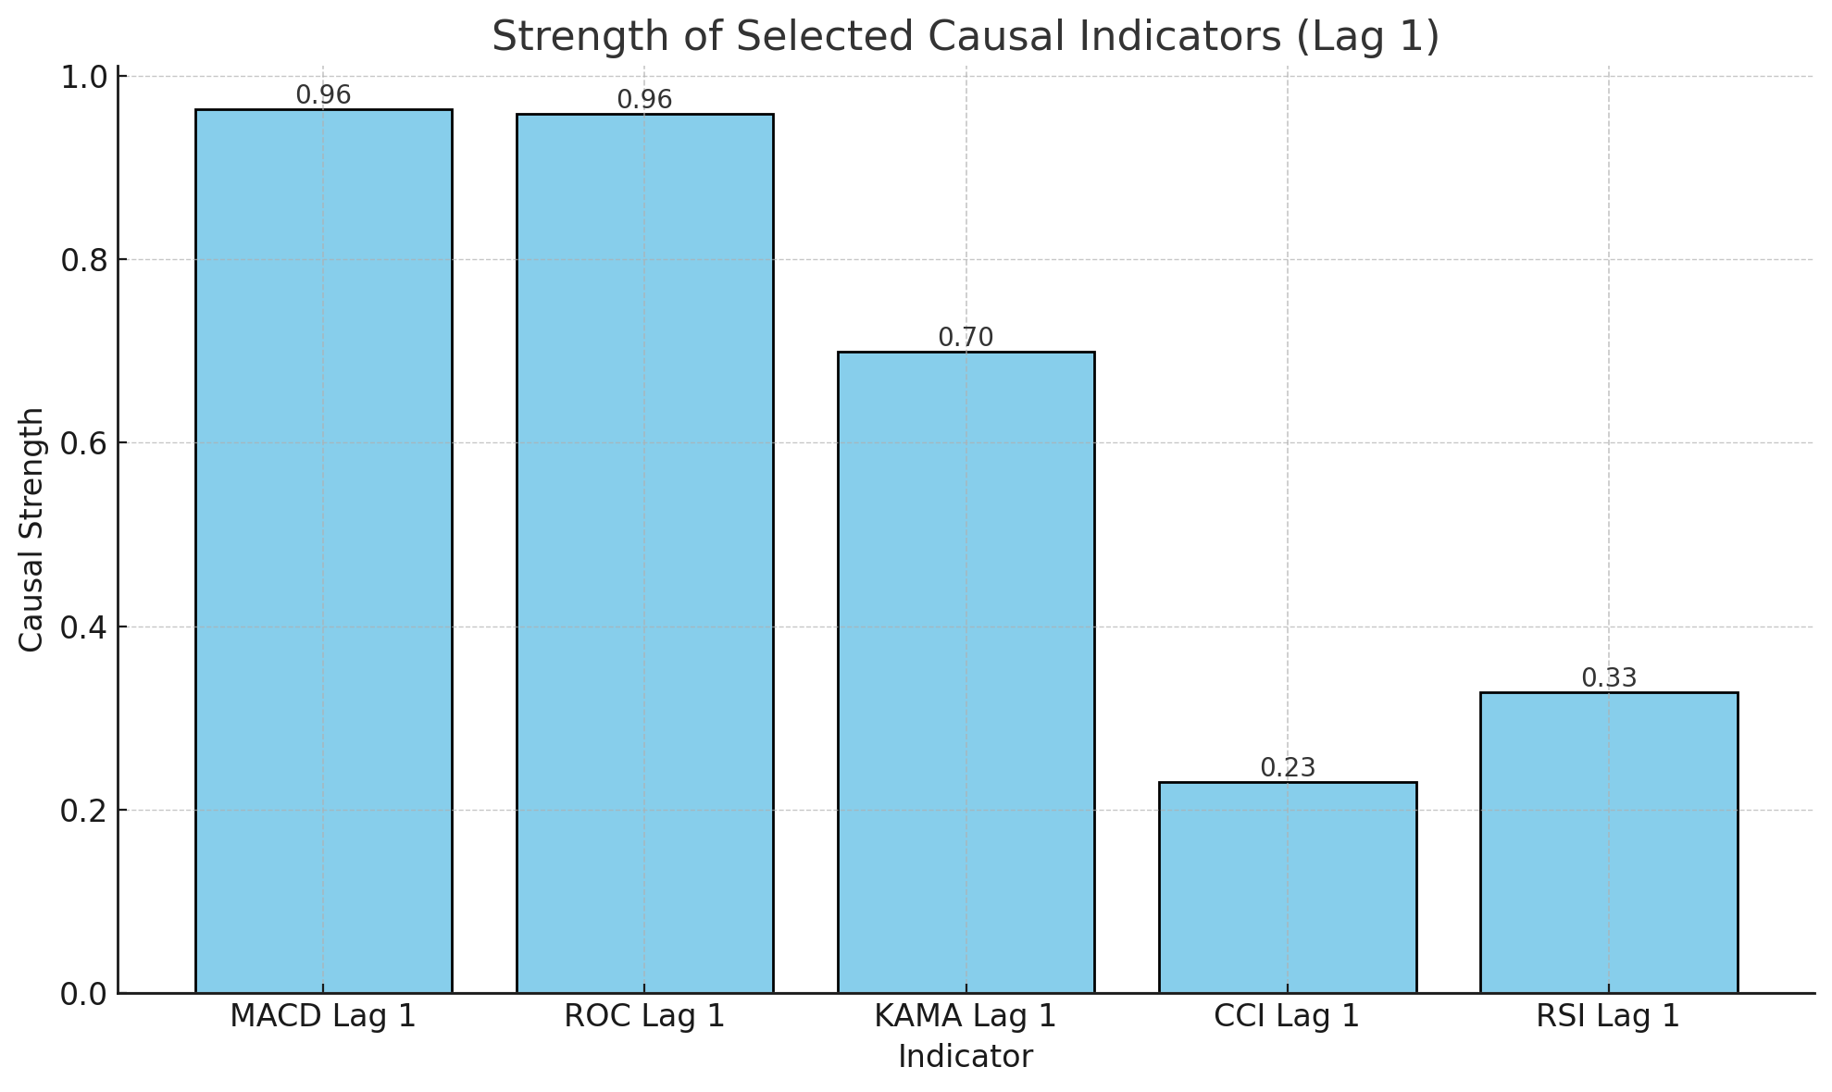
Fig.5: PCMCI top 5 results

The results from the PCMCI model seen in figure 5, identified ROC (Rate of Change) and MACD (Moving Average Convergence Divergence) as the two most causally significant indicators driving returns in the examined intraday stock data, with causal strengths of 0.98 and 0.96. There are multiple reasons why both of them are the strongest indicators, ROC is a momentum oscillator that captures the velocity of price changes so it makes it sensitive to abrupt shifts in market sentiment and price swings that are present in intraday prices. Similarly, MACD which is a trend following momentum indicator based on the relationship between two moving averages, provides a smoothed measure of price acceleration and/or deceleration. MACD excels at identifying micro trends in the markets which is really important in intraday trading. This is why MACD is one of the most popular indicators among day traders.

In contrast, other indicators such as KAMA (Kaufman's Adaptive Moving Average), CCI (Commodity Channel Index), and RSI (Relative Strength Index) showed lower yet effective causal strengths. They have effects on the price but in a weaker effect when compared to the ROC and MACD. The results show the importance of momentum based features in high frequency predictive modeling.

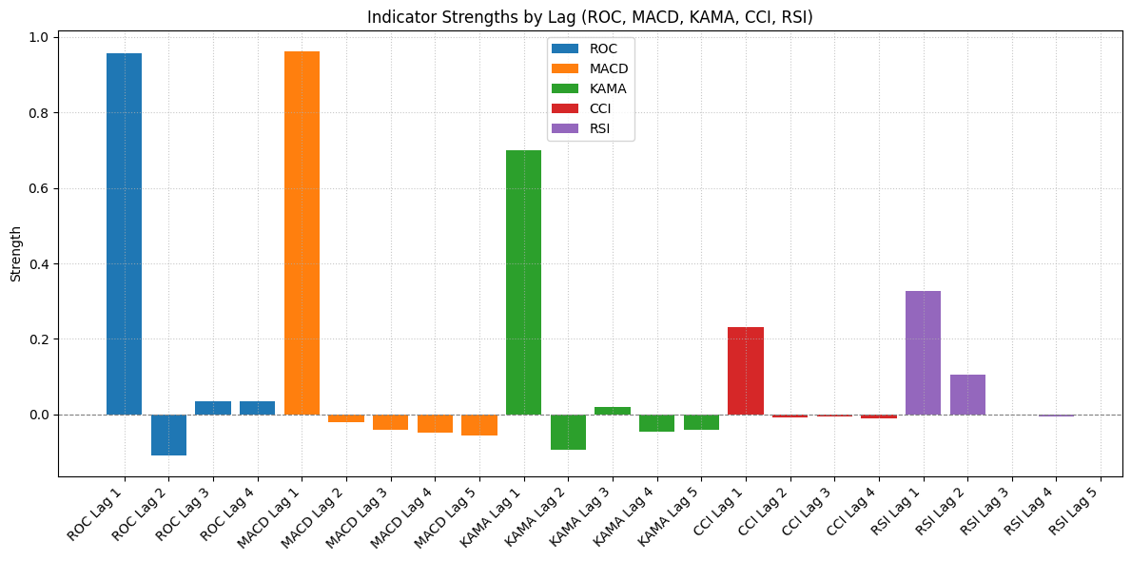
Fig.6: Top 5 Causal Indicators Identified by PCMCI and Their Lag Strengths

When digging deeper into the model results, the results show the strengths of the top 5 indicators in their last 5 lags. Beyond Lag 1, the PCMCI model reveals that most indicators show diminishing or even negative causal strength at longer lag intervals. This proves that the effects of the indicators are weekend as the time goes on. For example, ROC and KAMA both show negative strengths at Lag 2. This indicates that these indicators have an inverse effect on the price. MACD’s strength also gradually decreases from Lag 2 to Lag 5. Both RSI and CCI have slightly positive values at Lags 2 and 3 which suggests short lived influence. The results of the model further proves that actions taken based on indicators in intraday trading must be instant as the indicators effect worsen as time goes on. The presence of negative strengths may also point to overfitting risks which need to be considered in the models.

Due to the negative strengths in the PCMCI output which may indicate overfitting, particularly given the assumption of linear relationships through the use of partial correlation, we decided to pivot to using the 30 indicators and filtering the top 10 based on cumulative returns. Each oversold and overbought threshold value are searched up and set as the buy and sell signals accordingly. Here is the list of indicators with the parameters used:

Indicator | Parameters
AO | SMA(5), SMA(34)
Bollinger Bands | Length=20, Std=2
PSAR | Step=0.02, Max=0.2
Envelope (High) | SMA(20), Dev=+2%
OBV | —
VWAP | —
ADX | Length=14, Threshold=25
Ichimoku Cloud | Tenkan=9, Kijun=26, Senkou B=52, Shift=26
Std Dev Filter | Length=20
A/D Line | —
CMO | Length=14
Envelope (Low) | SMA(20), Dev=-2%
SMA Crossover | Length=20
RCI | Length=14
CCI | Length=20
MACD | Length(slow)=26, Length(fast)=12, Length(signal)=9
KAMA | Length=10, fast Smoothing Constant(SC)=2, slow SC =30
ROC | Length=14
EMA | Length=12
RSI | Length=7
MFI | Length=14
RVI | Length=10
Williams% | Lookback=14
PPO | Length(slow)=26, Length(fast)=12, Length(signal)=9
Stochastic Oscillator | Length=14, Smooth Length=3
IBS | —
CMF | Length=20
Table1: 30 indicators with their parameters

As seen in table 1, the 30 technical indicators selected are a mix of commonly used indicators in intraday trading. They cover a range of strategies including trend following tools like SMA and Ichimoku Cloud. Momentum indicators such as RSI and MACD and volatility measures like Bollinger Bands. There are also volume driven indicators like OBV. This mix of indicators will allow us to capture different aspects of market behavior. For each indicator, the commonly used strategies found online on forums were used.

Indicator | Buy Signal | Sell Signal
AO | AO crosses above 0 | AO crosses below 0
Bollinger Bands | Close < Lower Band | Close > Upper Band
PSAR | Trend flips to up | Trend flips to down
Envelope Upper | Close > Upper Envelope | Close < SMA
Envelope (Low) | Close < Lower Envelope | Close > Upper Envelope
Envelope (High) | Close > Upper Envelope | Close < SMA
MA Envelope | Close > Upper Envelope | Close < Lower Envelope
OBV | OBV ↑ and Close ↑ | OBV ↓ and Close ↓
VWAP | Close crosses above VWAP | Close crosses below VWAP
ADX | ADX > 25 and +DI > -DI | ADX > 25 and -DI > +DI
Ichimoku Cloud | Close > Cloud & Tenkan > Kijun | Close < Cloud or Tenkan < Kijun
Std Dev Filter | Std ↑ and Close > SMA | Std ↑ and Close < SMA
A/D Line | A/D ↑ and Close ↑ | A/D ↓ and Close ↓
CMO | CMO crosses above 0 | CMO crosses below 0
SMA Crossover | Close crosses above SMA | Close crosses below SMA
RCI | RCI < -80 | RCI > 80
CCI | CCI < -100 | CCI > 100
MACD | MACD > signal line & both below 0 | MACD < signal line
KAMA | KAMA < EMA200 | KAMA > EMA200
ROC | ROC crosses above 0 | ROC crosses below 0
EMA | EMA < Close | EMA > Close
RSI | RSI < 30 | RSI > 70
MFI | MFI < 20 | MFI > 80
RVI | RVI < -100 | RVI > 100
Williams% | Williams% < -80 | Williams% > -20
PPO | PPO < -10 | PPO > 10
Stochastic Oscillator | Oscillator < 20 | Oscillator > 80
IBS | IBS < 0.2 | IBS > 0.9
CMF | CMF < -0.25 | CMF > 0.25
Table2: Indicator strategies

Backtesting analysis of the 30 technical indicators was conducted, each tested with their most used parameter settings as seen in table 2. The backtesting was run on aggregated data at 1 minute and 2 minute intervals and compared them. The indicators were tested over a 1 year period between May 2024 and May 2025.

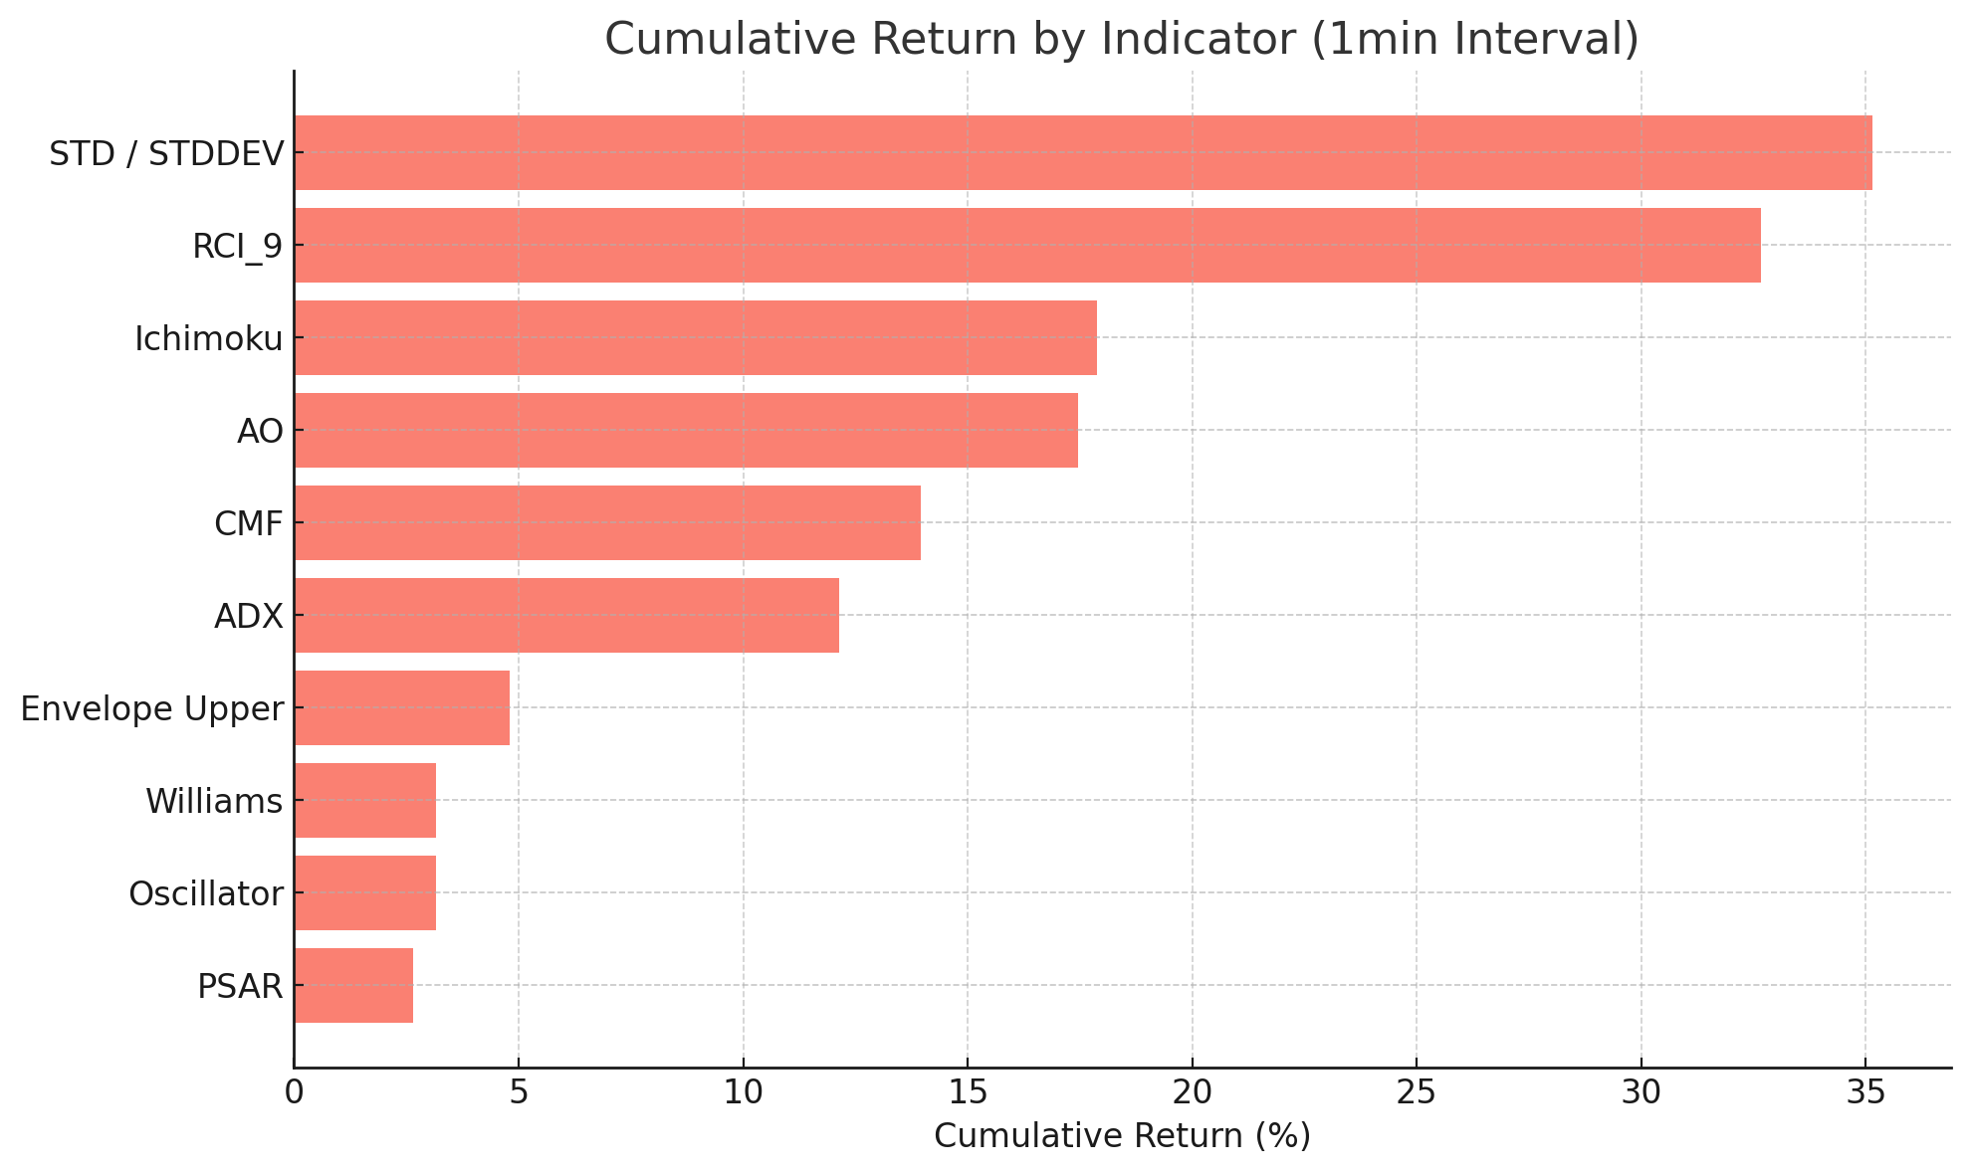
Fig.7: Top 10 indicators with highest returns in 1 minute interval

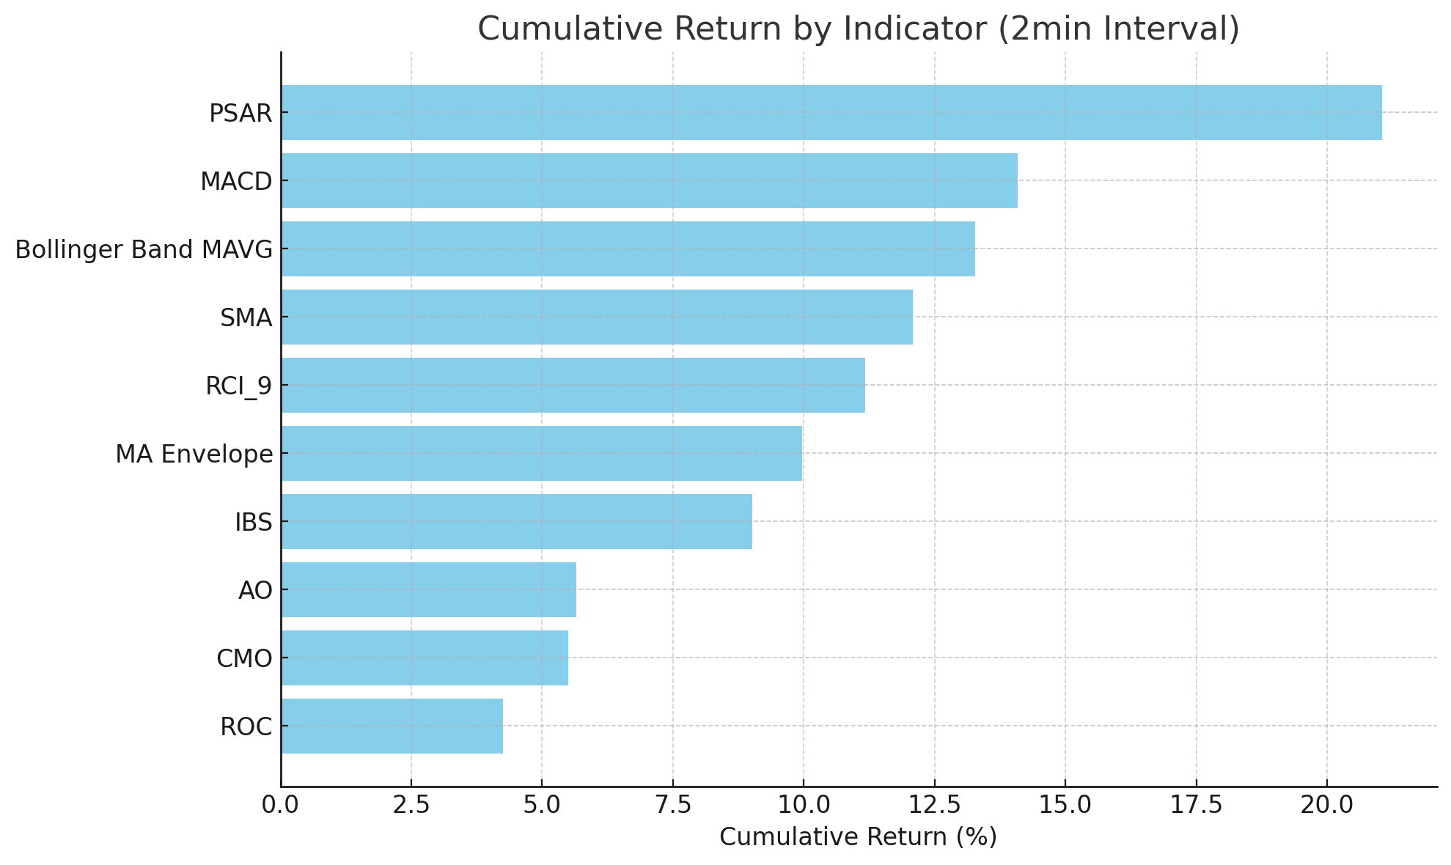
Fig.8: Top 10 indicators with highest returns in 2 minute interval

The analysis for the 1 minute and 2 minute data shows different sets of indicators excel at different intervals. Figure 7 illustrates that in the 1 minute interval dataset, volatility based indicators like the STD and the MACD had the best returns having a cumulative return of 35.14% and 32.67% respectively. This shows us the effectiveness of volatility on the price especially on the very short intervals. The trend following like PSAR underperformed within the same interval compared to the 2 minute intervals, showing their lagging nature.

On the other hand, the 2 minute interval returns show a narrower distribution, with PSAR achieving the highest cumulative return at 21.05%, followed by MACD (14.09%) and Bollinger Band Moving Average (13.28%) as seen in figure 8. Unlike the 1 minute intervals the importance of the volatility based indicators seemed to diminish. The graph further proves to us that each interval has its best indicators and there is no 1 size fits all. A deeper look was taken into the top 10 indicators for each interval and compare different aspects like the frequencies and the win rates:

1 min Interval
Indicator | Number of trades | Average return per day
STD | 2249 | 6.92E-06
RCI | 1250 | 6.19E-06
Ichimoku | 1666 | 5.34E-06
AO | 2121 | 3.71E-06
CMF | 434 | 3.81E-06
ADX | 371 | 3.48E-06
Envelope Upper | 14 | 1.44E-04
Williams | 2514 | 1.36E-06
Oscillator | 2514 | 1.36E-06
PSAR | 4592 | 8.12E-07
Table 3: Number of trades and daily returns for top 10 in 1 minute intervals

Table 3 compares the indicators based on the number of trades made throughout the year and the average return per day for each strategy. Indicators such as Williams %R, Oscillator, and PSAR show the highest number of trades, however this is not always a positive thing as more trades does not equal more profits and we could see that from the returns per day where the bottom 3 indicators in returns are the top 3 in trades made. On the other hand, indicators like the Envelope Upper, while generating very few trades (only 14), yielded the highest average return per day at 1.44E-04, suggesting that low frequency signals may offer higher quality trade opportunities and therefore more profits. Indicators with medium frequency trades like STD, RCI, and Ichimoku provided a balanced trade off where it does not have the highest returns but are more frequent.

1 min Interval
Indicator | Cumulative return | Max  Drawdown | Win Rate
STD | 35.14% | -16.49% | 35.22%
RCI | 32.67% | -18.92% | 36.64%
Ichimoku | 17.87% | -14.98% | 36.55%
AO | 17.45% | -17.94% | 32.77%
CMF | 13.95% | -26.10% | 61.73%
ADX | 12.18% | -21.41% | 39.35%
Envelope Upper | 4.79% | -2.75% | 61.54%
Williams | 3.15% | -24.73% | 65.23%
Oscillator | 3.15% | -24.73% | 65.23%
PSAR | 2.65% | -22.73% | 38.09%
Table 4: returns, max drawdown and win rate for top 10 in 1 minute interval

Table 4 then compares the cumulative returns with the max drawdown and the win rates. The STD and RCI indicators had the highest cumulative returns (35.14% and 32.67%) at the cost of moderate drawdowns (over 16%) and low win rates. These strategies had higher risks and low accuracy but have a strong overall return. In contrast, indicators like Williams %R, Oscillator, and CMF show higher win rates (over 61%), but their cumulative returns remained modest and their drawdowns are large (CMF at -26.10%) showing a trade-off between consistency and long term gains. Envelope Upper stood out with a strong win rate of 61.54% and the lowest drawdown (-2.75%) however it had only 14 trades so the results cannot be reliable without further testing.

2 min Interval
Indicator | Number of trades | Average return per day
PSAR | 2302 | 8.70E-06
MACD | 1166 | 8.40E-06
Bollinger Bands MAVG | 500 | 5.48E-06
SMA | 2923 | 6.20E-06
RCI | 627 | 5.63E-06
MA Envelope | 10 | 7.02E-06
IBS | 4143 | 4.40E-06
AO | 1049 | 3.49E-06
CMO | 2989 | 1.51E-04
ROC | 2960 | 2.97E-06
Table 5: Number of trades and daily returns for top 10 in 2 minute intervals

Table 5 shows the trading frequency and average daily return of the top 10 technical indicators applied to 2 minute interval data. PSAR and IBS recorded the highest number of trades indicating high signal frequency but that comes at the cost of the returns where it has average returns. On the other hand, CMO revealed the best performance, achieving the highest average return per day despite a high trading frequency (2989 trades) which suggests it generated both frequent and profitable signals. Indicators like MACD, RCI, and Bollinger Bands MAVG delivered a balance between trade count and average returns. The MA Envelope indicator also achieved good average returns but was based on only 10 trades, making its performance less conclusive due to the limited sample size.

2 min Interval
Indicator | Cumulative return | Max Drawdown | Win Rate
PSAR | 21.18% | -15.35% | 38.58%
MACD | 14.09% | -19.93% | 36.62%
Bollinger Bands MAVG | 13.28 | -16.08% | 64.20%
SMA | 12.08 | -21.02% | 25.38%
RCI | 11.17% | -25.28% | 38.60%
MA Envelope | 9.97% | -10.20% | 70.00%
IBS | 9.01% | -28.09% | 61.12%
AO | 5.65% | -21.59% | 35.27%
CMO | 5.50% | -24.19% | 33.52%
ROC | 4.25% | -23.58% | 33.82%
Table 6: returns, max drawdown and win rate for top 10 in 2 minute interval

Table 6 presents the cumulative return, maximum drawdown, and win rate for each indicator applied to the 2-minute interval data. PSAR led the indicators in overall performance with the highest cumulative return of 21.18%, mixed with a moderate drawdown of -15.35% and a win rate of 38.58%, which shows an aggressive but profitable strategy. Bollinger Bands MAVG and MA Envelope both showed strong win rates, with the MA Envelope also showing the lowest drawdown (-10.20%) however the MA Envelope only has 14 trades which may be the reason for having the lowest drawdown. IBS delivered a good win rate of 61.12% but suffered from the highest drawdown which highlights the significant downside of volatility despite the frequent wins. Indicators like MACD, RCI, and SMA offered moderate returns (all around 12%) but were accompanied by higher drawdowns and varied win rate. The ROC and the CMO recorded the lowest cumulative returns with substantial drawdowns.

- Baseline Model: (Brute Force)
The baseline model of this project is Brute Force Search (BF); it is also known as exhaustive search. It is an optimization algorithm that systematically checks all the possible combinations to find the best parameters within the defined search space to capture the global optimum. The goal of BF is to investigate whether alternative buy and sell thresholds exist which can yield higher cumulative returns for the top 20 selected technical indicators. It is important to be aware that threshold types vary across different technical indicators, such as numerical cutoffs, and crossover conditions. Commodity Channel Index (CCI) in table 7, for example, uses a numerical threshold to generate trading signals. The buy signal (oversold) is when CCI falls below -100, and sell signal (overbought) is when CCI rises above 100. A range of ± 50 is set up to around these standard thresholds, then BF will systematically examine each parameter within this range by a step size of 1 using the train set (earliest 70% due to time series analysis). Whenever a better cumulative return is discovered, the thresholds are updated, the iteration will stop until no better cumulative returns are found within the range. A typical crossover condition-based threshold is MACD technical indicator (Table 8), the buy signal occurs when the MACD line cross above the MACD signal line (9-period EMA of the MACD), and both are below the zero line., an intuitive approach is to set a range of ± 0.5 to around the zero line with a step size of 0.02. Then BF discovers when both MACD and its signal line is below -0.12, higher cumulative return is found compared to the zero line. Similarly, for EMA (Table 9), the standard trade signals use zero line as the reference point. In the BF optimization, the zero line is replaced with a 50-period EMA, which better reflects broader market trends. Additionally, support/resistance indicates the lower bound/upper bound which downtrend/uptrend is likely to reverse. The three tables (7,8,9) show the BF optimization results for CCI, MACD, and EMA as representative examples. As all the top 20 technical indicators are systematically examined, to avoid redundancy, only the three technical indicators are reported.
CCI | Standard Threshold | BF Optimization
Set | Trainset | Trainset
Buy | -100 | -134
Sell | -100 | 150
Sum of Return | 0.0186 | 0.2351
Cumulative Return (%) | 24.03 | 24.59
Avg Return per Trade | 1.40E-05 | 2.55E-04
Number of Trades | 1307 | 922
Table7. Brute Force: CCI
MACD | Standard Threshold | BF Optimization
Set | Trainset | Testset
Buy | macd > macd signal & < 0 line | macd > signal & < -0.12
Sell | macd <macd signal | macd < signal
Sum of Return | 0.047 | -0.0908
Cumulative Return (%) | 3.67 | -9.43
Avg Return per Trade | 2.80E-05 | -1.15E-04
Number of Trades | 1677 | 789
Table8. Brute Force: MACD
EMA | Standard Threshold | BF Optimization
Set | Trainset | Testset
Buy | ema12 < close | ema12 < ema50 & support = 0.002
Sell | ema12 > close | ema12 > ema50 & resistance = 0.003
Sum of Return | -0.0191 | -0.0128
Cumulative Return (%) | -3.23 | -2.13
Avg Return per Trade | -3.00E-06 | -5.00E-05
Number of Trades | 6023 | 258
Table9. Brute Force: EMA
Once the thresholds that yield higher cumulative returns for each technical indicator are identified, they are subsequently fed into the test set (30%) to evaluate whether these thresholds consistently perform better than standard threshold. However, the majority of these revised thresholds produce even lower cumulative returns, and often negative returns. This suggests that BF baseline mode fails to discover true meaningful threshold parameters that outperform the standard ones. These results illustrate the fact that the standard thresholds are established by extensive empirical testing and domain expertise. Additionally, stock trading is a complex regime where trading techniques cannot be improved by adjusting/optimizing indicator values. Nevertheless, it is crucial to investigate the potential reasons leading to the failure of applying BF to find better threshold values. First, as BF checks every possible parameter, the model could experience overfitting, meaning it took some outliers which perform well and took that as the threshold values. Secondly, the stock index pattern for the train set and test set are completely different, the train set is oscillating and still trending up, whereas the test set showed a continuous downward trend. The optimal thresholds collected from the train set become less applicable due to this change in trend. Last but not least, BF examined the optimal value at each indicator one by one, however, in real-life scenarios, trades used a combination of indicators and used multiple signals to make a holistic overview of whether to buy or not. If brute force was designed with such complex logic, the searching time would increase exponentially. Moreover, the combination may differ among people based on their own comprehension, making it difficult to objectively justify or standardize any particular combination within the brute force framework.

Advanced ML Models: (XGBoost, ANN)
For both the ANN and XGBoost models, three versions were developed: one using 1-minute single frame intervals, another with 2-minute single frame intervals, and a third multiframe model combining both. The trading logic is consistent across models and follows a binary classification approach, predicting only upward or downward movement. All models use the “Go Long” strategy meaning a trade is initiated only when an upward direction (class 1) is predicted otherwise, no trade is executed. The direction is determined by comparing the close price of the next candle (t+1) with the current close price (t), and the return is calculated as [close(t+1) - open(t+1)] / open(t+1).

If a trade signal is generated, the model buys at the open of the next candle and exits at its close. For example, using the 1-minute dataset, when the model predicts an upward movement at time t, it buys at open(t+1) and sells at close(t+1). In the multiframe 1 & 2-minute setup, it still enters at open(t+1) but exits at close(t+2), since t+2 is the earliest interval shared by both frames (the smallest common multiple of 1 and 2 minutes). This paper uses the multi-data frame approach backed by Gosh et al’s (2019) [1] paper which finds “The empirical results show that our multi-feature setting consisting not only of the returns with respect to the closing prices, but also with respect to the opening prices and intraday returns, outperforms the single feature setting”. This supports the idea that using both interday and intraday dynamics can significantly improve model performance over traditional single feature approaches.

For the models, the top 10 indicators shown in Figures 7 and 8 were used in their respective models. For the target variable, the 1-minute model makes a buy or sell decision every minute, while the 2-minute and multiframe models make decisions every two minutes. The multiframe version used the union of all indicators from Figures 7 and 8 (top 10 indicators for 1 minute and 2 minute intervals).

6.1. XGBoost
The models were used on 1 minute single intervals, 2 minute single intervals and a multiframe approach combining both 1 and 2 minute intervals into one dataset. The data was split 70% for training and 30% for testing. The first model applied was XGBoost. For XGBoost, a Keras Tuner was used to find the best parameters for each data frame.

XGBoost Models
Model | Accuracy
1 Minute Intervals | 52.81%
2 Minute intervals | 50.13%
Multi-frame | 54.36%
Table10.: XGBoost returns

The XGBoost classification model in the 1 minute single frame intraday data achieved an accuracy of 52.81%, with hyperparameters including n_estimators=300, max_depth=10, and a relatively low learning_rate=0.03. While the overall accuracy is only slightly above random chance (0.50). The model performed better in identifying the positive class (label 1), achieving a recall of 0.66 and an F1-score of 0.58, indicating a stronger ability to see instances where the stock price increases. In contrast, for the negative class (label 0), the recall dropped to 0.41, with a lower F1-score of 0.46, reflecting difficulty in correctly classifying downward or neutral price movements. The confusion matrix further shows this imbalance, with a significant number of false positives and false negatives. Overall, the model demonstrates modest predictive power, showing greater sensitivity to price increases but lacking robustness in generalizing across both classes.

The 2-minute intervals had the worst accuracy out of all the models, with an accuracy of 50.13%. The XGBoost model, tuned with a subsample of 0.9, 700 estimators, a learning rate of 0.05, and a max depth of 6, showed no meaningful predictive advantage over random guessing. The classification report reflected balanced but weak performance as seen in figure 9, with precision, recall, and F1-scores hovering around 0.50 for both classes. The confusion matrix further confirmed this, showing nearly equal correct and incorrect classifications, indicating the model struggled to capture any significant patterns at this frequency.
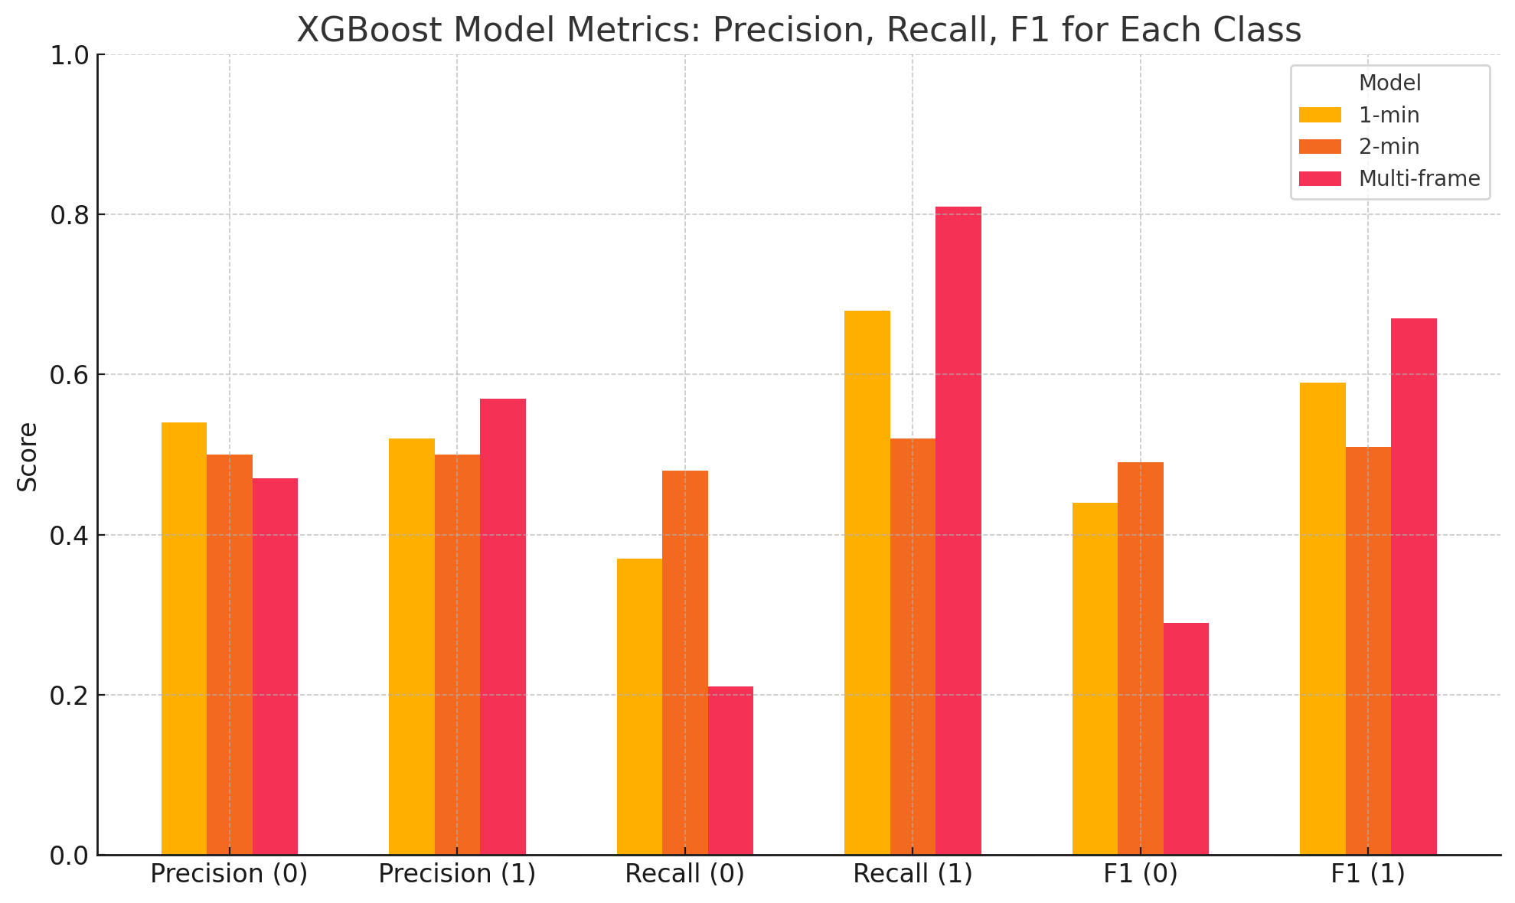
Fig.9.: recall,precision and f1 for buy and sell

The multi-timeframe XGBoost model, which integrates both 1-minute and 2-minute features, achieved a higher classification accuracy of 54.36%, indicating an improvement in predictive power compared to the single frame model. With optimized parameters including n_estimators=300, max_depth=6, and a conservative learning_rate=0.01, the model showed a clear bias toward correctly identifying upward price movements. The recall for class 1 (price increase) reached 0.83, with an F1-score of 0.67, demonstrating strong sensitivity to positive returns. However, performance for class 0 (price down) was a lot weaker, with a recall of just 0.21 and an F1-score of 0.29. This imbalance is further reflected in the confusion matrix, where the model correctly classified 3,064 out of 3,699 positive cases but misclassified the majority of negative cases. While the precision and recall hover around 0.53–0.55, the results suggest that the multi-timeframe approach improves detection of profitable long opportunities but does so at the cost of false positives, especially in sideways or bearish market conditions like our test data.

6.1.1 Experimental Results and Analysis:

The results for the single frame XGBoost results are not promising as initially thought, the model performance without fees has a return of 317% that is because the model has very small margins with around 15.5k trades which adds up and inflates the cumulative return. The buy and hold at the same time had a return of around -20% which indicates a down market in the testing time period. The model struggled when the transaction fees were added. For the transaction fees the model used the least damaging fees found from Interactive Brokers where on average users pay 1 dollar every 10k trades (0.004% per trade) while trading below a certain amount. When implementing the fees, returns decrease to around -30% return as seen in figure 10.
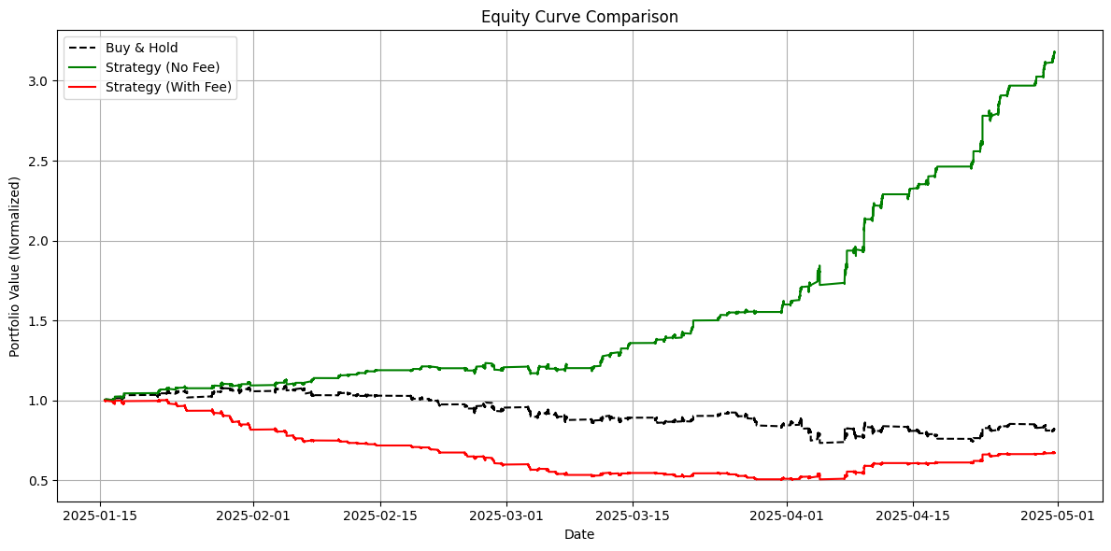
Fig.10. 1 minute returns with and without fees vs buy and hold

Figure 11 shows the 2 minute intervals returns, the XGboost made 6766 total trades with a cumulative return of -47.79% (with fees). Without fees the return is 3% which beats the buy and hold. Even though the 2 minute single frame interval has the worst accuracy out of all the XGBoost models, the returns are not the worst and this proves that model accuracy can not be the only metric used to evaluate a model.

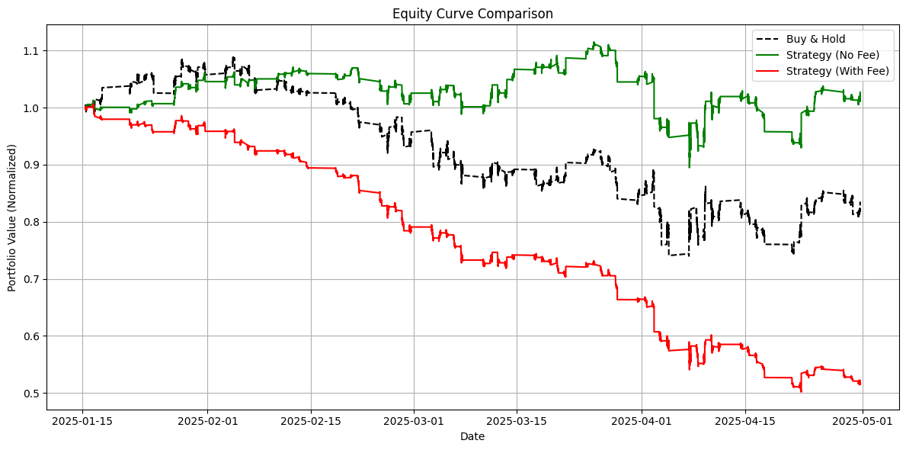
Fig.11. 2 minute returns with and without fees vs buy and hold

For the multiframe XGBoost, the returns are worse in both the with fees and the without fees as seen in figure 11. The returns without fees is around -17% which is just a little better than the buy and hold but when factoring in the fees, the returns becomes -92% which is the worst performing model. The model executed over 6,000 trades across the 5 month period. While the model captured some directional movements, the average return per trade was negative. This high turnover combined with small profits was highly sensitive to transaction costs, leading to compounded losses. These results highlight the importance of incorporating transaction cost analysis early in model evaluation and it also shows the risks and dangers of high frequency trading.
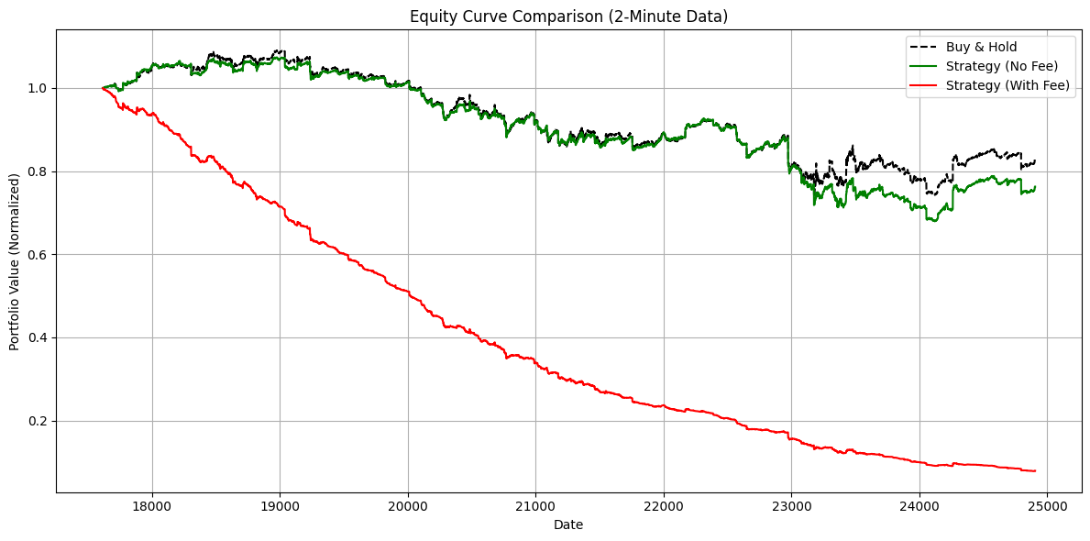
Fig.12. Multi frame returns with and without fees vs buy and hold

XGBoost
Interval | Average Daily Return (no fee): | Average Daily Return (with fee):
1 Minute | 0.0166 | -0.0052
2 Minute | 0.00015 | -0.0114
Multi-frame | -0.1934 | -0.7366
Table11. Daily return comparison with and without fees

When looking at the daily returns for each XBoost model, the big differences start to appear between each interval. The 1 minute model outperforms all other intervals when factoring in return both with and without fees. The multi-frame model struggled the most even though it had the highest accuracy of them all. This further proves that model accuracy does not translate into return.

XGBoost
Interval | Number of Trades | Cumulative Return ( no fees) | Cumulative Return (fees)
1 Minute | 15,261 | 326% | -33.56%
2 Minute | 6,766 | 4.63% | -47.79%
Multi-frame | 5,336 | -16.71% | -92.13%
Table12. Number of trades and returns of models with and without fees

Overall, the results show a clear decline in cumulative return as the trading frequency decreases even when compared to the buy and hold which has a cumulative return around -20%. We could see the 1 minute interval executed the highest number of trades (15,261) with a cumulative return of -33.56%, while the 2-minute and multi-frame setups made fewer trades and saw even larger losses of -47.79% and -92.13%. This highlights the consistent underperformance of all strategies after accounting for trading fees, with returns worsening at lower trade frequencies. This also further proves that model accuracy does not equal returns as the multiframe model had the highest accuracy but the lowest returns.

6.2 Artificial Neural Network (ANN):
The second model applied to predict the binary direction of the stock index is Artificial Neural Networks (ANN). In recent research, ANN has been employed with the Directional Change (DC) framework, which is categorized to an event-based paradigm, to capture trade signals based on the dynamic threshold. (Kampouridis et al., 2017)[11]. A similar study conducted by Chang et al (2011) [10] shows that after including fees and tax, The rate of return achieved by ANN model ranges from 3.87% to 63.13% among 6 stock indexes (e.g., Apple, BA) Moreover, a hybrid model combining ANN and Principal Component Analysis (PCA) was applied to make directional prediction at E&P 500 on a daily basis. With PCA dimensionality reduction from 60 to 31 PCs, the best hybrid model gives 60.4% overall model accuracy. (Zhong, et al., 2019). Previous studies have illustrated the feasibility of ANN models for directional prediction at stock indices. As ANN is classified within the deep learning regime, by comparing it with XGBoost the project aims to assess which methodology may achieve superior results in the context of high-frequency intraday trading.
Neural networks work differently than a XGboost where the ANN requires a lot more tuning but in return the model understands more complex relations. Among different types of Neural networks, the model uses multilayer feed-forward network, also known as multi layer perceptron (MLP) that adopts back-propagation algorithm, where weights are backward adjusted from the output layer to minimize the difference between predicted and actual values, measured by mean squared error (MSE). Due to the nature of time series analysis, the dataset is split into 60% as the train set, 10% after the train set is validation (60%-70%), and the rest of 30% is the test set (70%-100%). ANN consists of an input layer, multiple hidden layers and output layer. Each neuron receives signals from connected neurons. The output from these neurons is processed through the activation function. The model architecture includes a single input layer, where the number of neurons corresponds to the number of numerical features provided as input. No categorical or other data types are used. The model has initial 2 hidden layers and will increment by 2; the same design is applied to the number of hidden neurons. The activation function is ‘relu’ in hidden layers as its merits for avoiding vanish gradient and high training efficiency. The activation function for the output layer is ‘sigmoid’ as the model aims to produce binary results.
To investigate the optimal model performance, the first step is to apply an empirical method that iteratively testing different numbers of hidden layers at the 1min AMAZON dataset. The Table13. shows that the MSE for train, test, and validation fluctuate around 0.25; the accuracies at each set also fluctuate around 50%. After testing various hyperparameter settings, no single model achieved the best performance across all metrics (accuracies and MSEs). As a result, overall accuracy is used to facilitate the comparison between models. This iterative approach was also applied to the 2-minute and 1&2-minute multiframe datasets to determine the hyperparameter settings that yielded the best performance. To avoid redundancy, the report presents the complete iteration results only for the 1-minute dataset. The best performing models for the 2-minute and 1&2-minute datasets are listed in Table 15.

1min ANN
Number of layers | Train Accuracy% | Train MSE | Test Accuracy% | Test MSE | Validation Accuracy% | Validation MSE | Overall Accuracy%
2 | 51.42 | 0.2497 | 50.35 | 0.2508 | 49.61 | 0.2506 | 50.46
4 | 51.43 | 0.2495 | 50.55 | 0.2509 | 49.53 | 0.2521 | 50.50
6 | 51.2 | 0.2497 | 50.6 | 50.6 | 49.69 | 0.25 | 50.50
8 | 50.97 | 0.2499 | 50.67 | 0.25 | 50.3 | 0.25 | 50.65
10 | 50.56 | 0.25 | 50.6 | 0.25 | 50.32 | 0.25 | 50.49
Table13. Performance Testing of 1-Minute ANN Model
The second step is to apply PCA that reduces the dimensionality of features on the 1min dataset based on the best hyperparameter setting. As several studies have demonstrated that PCA application does enhance machine learning models accuracy. (Shah et al., 2019). Table 14 presents the results of the iterative process by testing different numbers of principal components (PCs) to investigate the optimal configuration. Notice that there are 10 technical indicators for both 1min and 2min sets, nevertheless, the number of features in each set is different as some technical indicators are composed of multiple features. For example, the indicator “Ichimoku” consists of “Ichimoku base line”, “Ichimoku conversion line”, “Ichimoku a”, “Ichimoku b”. The PCA process begins with the number of PCs equal to the number of features in each set, then decreases the number of PCs by two in each run, and collects accuracies correspondingly. By repeating the optimization process for 1min, 2min, and 1&2min dataset, the best results for each model are presented in Table 15. The 1min timeframe model with 17 PCs reflects noticeable improvement across all accuracy metrics, and including a 5.29% (50.65% without PCA) increase in overall accuracy. 1&2min multiframe model with 40PCs also shows an increased overall accuracy by 2.94%(50.78& without PCA). However, the 2 min time frame model is not benefited from the PCA process as there are no significant changes in the overall accuracy before and after the application of PCA.

1min ANN_PCA
PCs | Train Accuracy% | Test Accuracy% | Validation Accuracy% | Overall Accuracy%
17 | 56.41 | 55.83 | 55.57 | 55.94
15 | 56 | 55.6 | 55.44 | 55.68
13 | 56.43 | 55.46 | 54.5 | 55.46
11 | 56.42 | 56.33 | 55.48 | 56.08
9 | 50.48 | 49.58 | 49.48 | 49.85
7 | 50.89 | 49.77 | 49.91 | 50.19
Table14. PCA Optimization for 1-Minute ANN Model

Best models comparison
Timeframe | Train Accuracy% | Test Accuracy% | Validation Accuracy% | Overall Accuracy%
1min | 50.97 | 50.67 | 50.3 | 50.65
1min(17PCs) | 56.41 | 55.83 | 55.57 | 55.94
2min | 51.08 | 50.66 | 50.31 | 50.68
2min(13PCs) | 51.8 | 50.54 | 50.06 | 50.80
1&2min | 51.14 | 51.26 | 49.94 | 50.78
1&2min(40PCs) | 56.84 | 52.05 | 52.27 | 53.72
Table15. Best performance model for each dataset
The tables of accuracies and mse provides a general measurement of predictive performance by each model. To further investigate each model’s performance at correctly predicting the binary classes (1 for upward, 0 for downward), the comparative classification reports for each time frame model with and without PCA offers more details regarding precision, recall, and F1 score. In Fig.13, the comparison between 1min (blue) and 1 min with the PCA model(orange) reflects the consistent improvement among the most metrics. For class 0, PCA model shows steady gains in precision and recall, and thereby the F1 score increases subsequently. The PCA model also achieves more balanced results in terms of correctly identifying the upward and downward direction than the original model which is highly imbalanced in recall for class 0(0.39), class1(0.62) and lower F1 score(0.44).
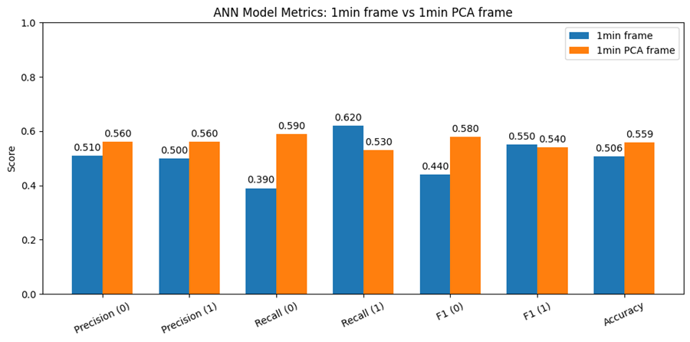
Fig.13. Classification report: 1min standard vs. PCA
Fig.14 shows the classification comparison between 2 min and 2min PCA model. Both models have almost identical precision for both class0(0.51) and class 1(0.5). The chance of correct prediction is about half. In terms of recall, the standard 2min model has much higher recall for class0(0.78) than class 1(0.22), indicating that the model is better at predicting downward movement, but missing a lot of upward movement. The 2min PCA model shows a contrast result, where the class1(0.85) is much higher than class 0(0.16). The F1 score reflects this contrast correspondingly; the standard 2min model has a high F1 score at class0 whereas the 2min PCA model has high F1 score at class1. The PCA process shifted the emphasis of predicting direction, however, the model does not improve the overall accuracy.
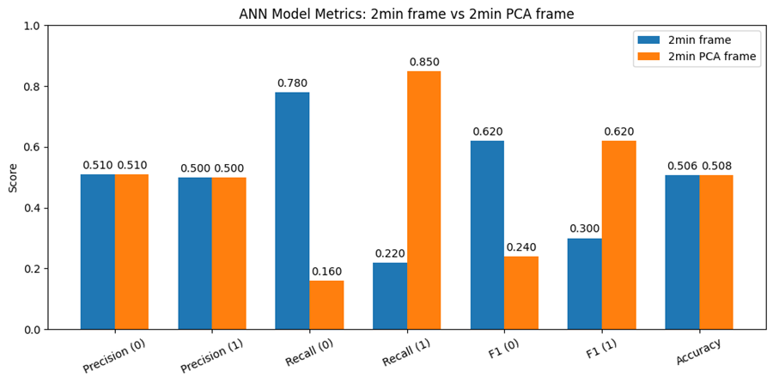
Fig.14. Classification report: 2min standard vs. PCA
Fig. 15 shows all the metrics for standard 1&2min and with PCA models. The standard 1&2min’s pattern mirrors the result in the standard 2min model which experiences imbalanced recall for high values in class 0 and low values in class1. The PCA model has improved precision in both classes; improved recall and F1 score in class1. The PCA process does enhance the model performance.
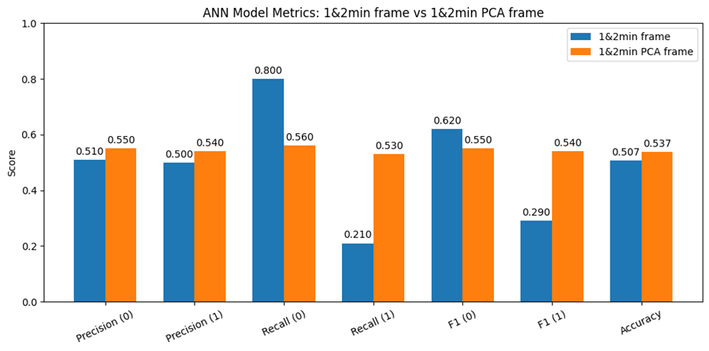
Fig.15. Classification report: 1&2min standard vs. PCA

6.2.1. Experimental Results and Analysis:
Fig.16 and Fig.17 reflect the cumulative return equity curves for 1 min and 1min PCA throughout the test set spanning from Jan.10.2025 to May.1.2025. The cumulative return calculation allowing the model to start with the trade with default initial capital (1 dollar) and reinvesting with gains and losses are considered to show the compounding results after a series of trading decisions. The black line represents the equity curve of buy and hold strategy as the benchmark; the green line represents the equity curve of ANN strategy with no transaction fee, and the red line represents the ANN strategy whose transaction fee is taken into account. Figure 16 shows that ANN model just performs slightly better than the buy and hold strategy. However, the red line collapsed quickly once the transaction cost was added, shown by the red line. The cumulative return drops from 16.03% to -99.98% (Table16). Figure 17, shows the equity curve after applying the PCA process. On the contrary, the cumulative returns boost vastly to 566.86%; the green line rises much beyond the original 1min model and the buy and sell benchmark. However, the PCA model still faces the same issue that the returns drop to -95.7% if the transaction cost is applied. Although the 1min PCA model demonstrates a significant enhancement, it still suffers from the incremental transaction cost due to the nature of high frequency intraday trading.
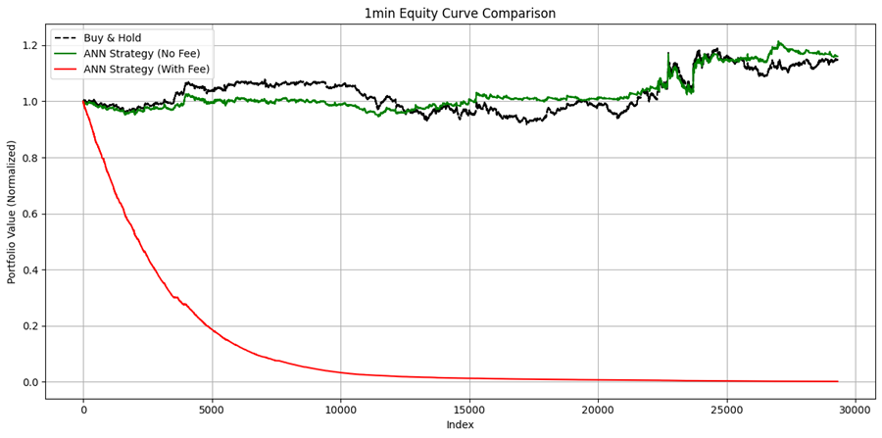
Fig.16. 1min Equity Curve
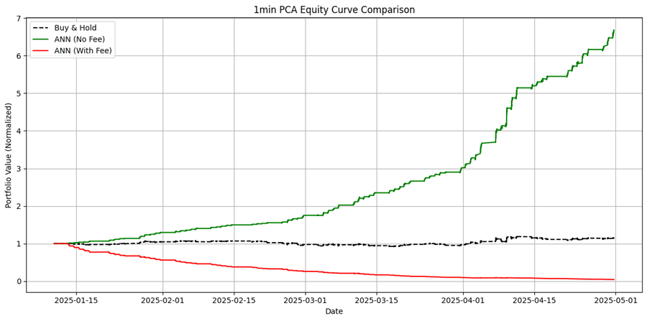
Fig.17. 1min PCA equity Curve

Fig.18 and Fig.19 also compare the standard 2min and its PCA model. Even though the PCA model has similar overall accuracy with the standard model, the PCA variant demonstrates a moderate improvement in cumulative return (7.69%) (Table16) compared to its standard model (0.83%). This is attributed to the successful capture of the two uptrends which occurred around Feb 1st and April 15th. However, despite the improvement, both models face the same issue as above mentioned, the cumulative returns are eroded by transaction cost.
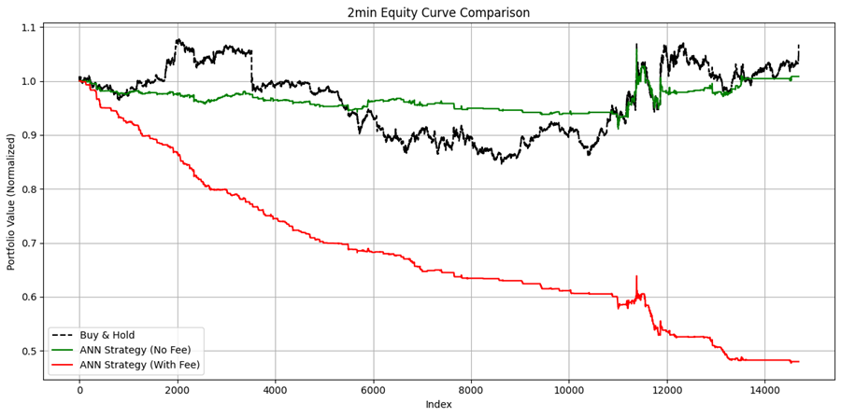
Fig.18. 2min Equity Curve
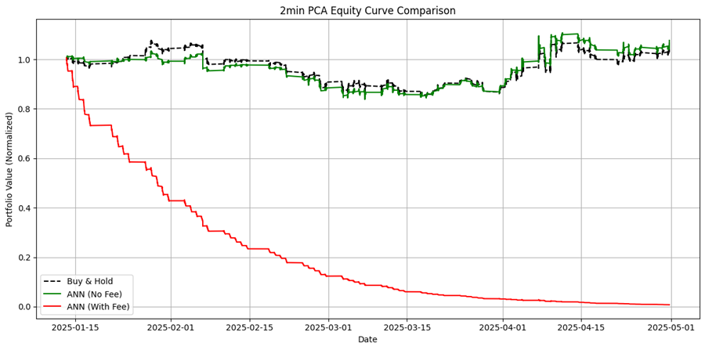
Fig.19. 2min PCA Equity Curve

Fig.20 and Fig.21 follow the same idea of comparison. Differing from the previous two sets, the standard 1&2min model (no fees) already shows a steady outperformance of buy and hold strategy with a cumulative returns of 50.36%.(Table16) The PCA model consistently shows a better result with a cumulative return of 78.34%. Yet, once the transaction applied, both models’ returns dropped to 87.52% and 91.19% respectively. Nevertheless, the cumulative returns with transaction fees for both 1&2min models are comparatively less negative than 1 min model. This is due to the fact that the multiframe model naturally has fewer trades as it operates on longer trading intervals. This validates the significant impact of a high number of trades on the model performance.

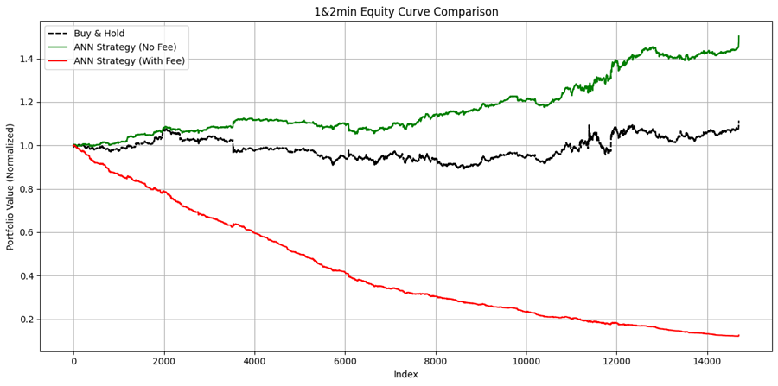
Fig.20. 1&2min Equity Curve
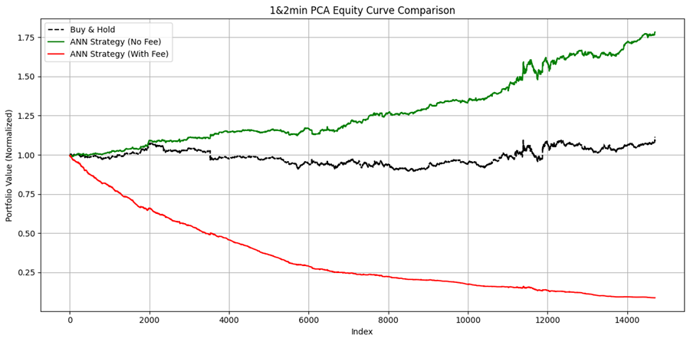
Fig.21. 1&2min PCA Equity Curve

ANN
Interval | Number of Trades | Cumulative Return (no fees) | Cumulative Return (fees)
1min | 15,261 | 16.03% | -99.89%
1min_PCA | 12613 | 566.86% | -95.70%
2min | 1856 | 0.83% | -52.01%
2min_PCA | 12337 | 7.69% | -99.23%
1&2min | 6222 | 50.36% | -87.52%
1&2min_PCA | 7518 | 78.34% | -91.19%
Table16. Cumulative Returns (With and Without Transaction Fees)

Table17 shows the average daily returns for each model providing an alternative perspective of the model performance. The result reinforces the earlier findings that regardless of the gross returns, transaction costs will ultimately overwhelm the profits.

ANN
Interval | Number of Trades | Average Daily Return (no fee): | Average Daily Return (with fee):
1min | 15,261 | 0.0021 | -0.0675
1min_PCA | 12613 | 0.0254 | -0.0419
2min | 1856 | 0.0002 | -0.0112
2min_PCA | 12337 | 0.0012 | -0.0646
1&2min | 6222 | 0.0055 | -0.0276
1&2min_PCA | 7518 | 0.0078 | -0.0323
Table17. Avg. Daily Returns (With and Without Transaction Fees)

Proposed Model & Performance on Other Stocks:
After evaluating the performance of all XGBoost and ANN models (both single and multi-frame), the XGBoost model using 1 minute intervals showed the best cumulative returns after factoring transaction cost into account with an average accuracy of around 53%, making it the model of choice for further testing. To evaluate the robustness of the model developed for AMZN, it was back tested on three additional technology stocks from the NASDAQ: META, Microsoft (MSFT), and NVIDIA (NVDA). Across all model predictions, the trading methodology, transaction costs (0.01%), and criteria for triggering trading decisions were held constant to ensure fair performance comparison. This evaluation aimed to assess how well a model trained on one asset performs when applied to others within a similar sector but with potentially different market dynamics. The analysis included classification performance metrics as well as cumulative return curves comparing the model driven strategy against a passive buy and hold benchmark, both with and without transaction fees.

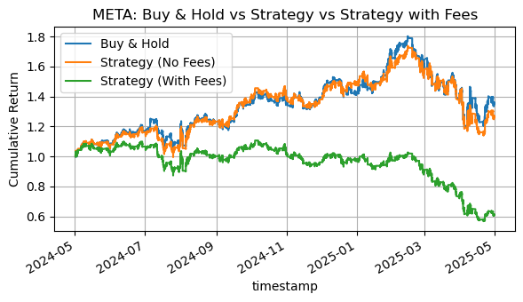Fig.22. Backtest of 1-Minute Trading Strategy on Meta Stock

When applied to META, the model achieved an accuracy of 50.56% with an imbalance in class prediction. The classification report revealed a high recall for the positive class (0.92), while the negative class recall is low (0.08). This indicates the model strongly favored predicting upward price movements and struggled with predicting downwards price movements. The buy and hold cumulative return for META was 1.36 (36%), while the model strategy produced a lower return of 1.2689 (26.98%) before fees. After factoring in the fees on the 7282 executed trades, the strategy’s return decreased to 0.6126 (-38.74%).

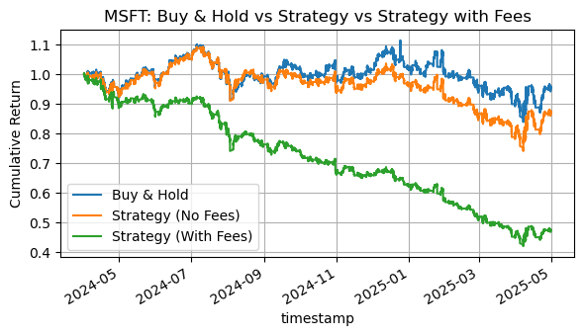Fig.23. Backtest of 1-Minute Trading Strategy on Microsoft (MSFT) Stock

The model was then evaluated on Microsoft stock (MSFT). The overall accuracy reached 50.78%, once again showing an imbalance in class predictions. The classification report indicated a high recall for the positive class (0.94) while maintaining a low recall of 0.07 for the negative class, similar to the bias observed in the META backtest. The buy-and-hold strategy resulted in a cumulative return of 0.9555 (-4.45). The model strategy had a cumulative return of 0.8728 (-12.72%) before fees. After incorporating transaction costs on 6100 trades executed, the net return further declined to 0.4742 (-52.58)
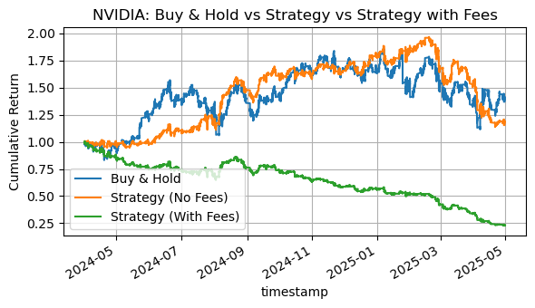Fig.24. Backtest of 1-Minute Trading Strategy on Nvidia (NVDA) Stock

Finally, the model was tested on NVIDIA (NVDA) stock. Unlike the previous backtests, the classification performance on NVDA was balanced. The model achieved an accuracy of 50.39%. The classification report showed nearly equal recall values for both the positive (0.43) and negative (0.58) classes. The model struggled in finding the directional movement of the NVDA stock however it did not have biases like it did with the META and MSFT stocks. The buy and hold cumulative return was 1.4057 (40.57%) while the model strategy showed a lower cumulative return of 1.1854 (18.54%) before transaction costs. However the biggest difference in this model was the number of trades. The model strategy executed 16,322 trades which severely decreased the cumulative return of the model with fees to 0.2318 (-76.82%).

Asset | Accuracy (%) | Positive Class Recall | Negative Class Recall
META | 50.56 | 0.92 | 0.08
MSFT | 50.78 | 0.94 | 0.07
NVDA | 50.39 | 0.43 | 0.58
Table17. Recall and Accuracy comparison for all 3 stocks

Across all 3 stocks the accuracy for the model is around 50% which proves the model struggles with predicting the direction of the price movements. For META and MSFT, the model showed a strong bias toward predicting positive price movements with a high positive class recall values of 0.92 and 0.94 while failing to identify negative price movements (recall of 0.08 and 0.07). On the other hand, NVDA showed more balanced performance with recall values of 0.43 for the positive class and 0.58 for the negative class.

Asset | Number of Trades | Buy & Hold Return | Strategy Return (No Fees) | Strategy Return (With Fees)
META | 7282 | 36% | 26.89% | -38.74%
MSFT | 6100 | -4.45% | -12.72% | -52.58%
NVDA | 16322 | 40.57% | 18.54% | -76.82%
Table 18. Comparison of Number of trades, buy and hold and the strategies with and without fees

For trading performances, the model based strategy underperformed when compared to the buy and hold for all 3 stocks especially when adding transaction fees. While the cumulative returns before fees for META (1.2689), MSFT (0.8728), and NVDA (1.1854) appeared competitive when compared to the buy and hold, the high number of trades executed, especially in NVDA (16,322 trades), led to a massive decrease in returns. After including a transaction fee of 0.01% per trade, the cumulative returns dropped significantly in all 3 stocks. The findings further prove the effects of the transaction costs in high frequency trading.

Discussion:
The best performing advanced model (XGboost), which is selected based on the cumulative return with transaction fees that reflect real-world trading outcomes, failed to meet the project objective (55%%-60% overall accuracy). Several factors could account for the deficiency in the model performance.
Firstly, the feature selection plays a crucial role throughout the model development. Initially, three different feature selection methods were applied to find the best technical indicators, The results from PCMCI were promising however the assumption of linearity may have caused overfitting forcing the use of basic backtesting to see the top cumulative returns. Both advanced models (ANN and XGBoost) still experienced relatively low overall accuracies fluctuating around 50%-55%. Taking a closer look into the selected techniques for feature selection, they vary in the intended purpose where the PCMCI was looking for statistically significant indicators while the other methods were looking for the best cumulative returns.
The hybrid GA-ANN model by Qiu et al (2016) examined two subsets of technical indicators on Nikkei 225 index, with subset1 composed of mixture of momentum-based and trend-based indicators which serves different purpose of analysis, whereas subset2 composed of a series of trend trend-based indicators only. The subset2(81.27%) achieved a 20.4% higher hit ratio (correctly predicted the upward direction) than subset 1(60.87%). This observation from the paper proved that feeding indicators with different purposes could introduce conflict signals, making the machine learning model difficult to capture underlying patterns. Although an increased number of indicators do introduce more information, the predictive power could be diminished if indicators’ functionalities are not aligned.
Additionally, the project aims to investigate the forecasting capability of ML models in intraday stock index, specifically focusing at high frequency 1 min and 2 min time intervals. Such short intervals are noisy and convey less useful information or underlying patterns than day trades. According to Tang et al. (2023), an ANN-based model for intraday financial forecasting utilized a minimum window size of 10 minutes , since longer intervals potentially contain more useful information and noise is inflated. In forex trade, which is known for hyper liquidity and trading frequency varies from seconds to minutes, the strategies often rely on microstructure indicators instead of technical indicators. Therefore, the initial scope of 1 min and 2 min are in an awkward position that are neither short enough to leverage micro techniques in the hype -liquid market, nor belong to the 10 min region that is more statistically robust.
.
- Conclusion:
The study investigated the forecasting capability of both rule-based and machine learning algorithms at a 1-year intraday dataset of 1min, 2min and 1min&2min timeframes for Amazon (AMZN). The feature selection approach identified the top 10 technical indicators in 1 min and 2min dataset respectively and utilized the top 18 (2 are repeated) indicators in the 1&2min multi-timeframe dataset.
Brute Force was executed as the baseline model, which exhaustively searched for optimal threshold parameters of these indicators that were beyond the standard ones. The goal of the baseline model aimed to examine whether optimizing the buy and sell thresholds for specific stock indexes can result in better profits. However, these optimums failed to generate more returns out of sample. For the advanced models, XGBoost and ANN function as the binary classification models that make predictions on the direction of the next candle. Yet both models gave modest predictive accuracies that below 60%. The results reflect the noisy nature of high-frequency intraday trading, as well as the importance of feature selection; Theoretically, the quantity of features were sufficient for modelling analysis, yet more numbers of features unnecessarily deferred more predictive power. The 1min XGBoost model was considered as the best performing model based on its cumulative returns with transaction fees taken into account. To further examine the model’s consistency and robustness, it was applied to the other three stock indices (META, MSFT, NVDA). The best cumulative returns achieved 40.57% indicating XGBoost consistently generated profitable predictions. However, once the transaction cost was included, all the models experienced negative cumulative returns. Considering each return is intrinsically small given 1 min and 2min timeframes, the profits are overwhelmed by transaction fees once the number of trades incremented. By understanding these limitations and constraints, further modelling may consider alternative data sources, features with similar functionalities, and diversify trading strategies such as go short or different buy and sell logic.

- References:
[1] P. Ghosh, et al., “Forecasting directional movements of stock prices for intraday trading using LSTM and random forests,” *Finance Research Letters*, vol. 46, 102280, 2022. [Online]. Available: https://doi.org/10.1016/j.frl.2021.102280

[2] Y. Shynkevich, T. M. McGinnity, S. A. Coleman, A. Belatreche, and Y. Li, “Forecasting price movements using technical indicators: Investigating the impact of varying input window length,” *Neurocomputing*, vol. 264, pp. 71–88, 2017. [Online]. Available: https://doi.org/10.1016/j.neucom.2016.11.095

[3] P. D. Nguyen, et al., “Deep learning-based predictive models for forex market trends: Practical implementation and performance evaluation,” *Science Progress*, vol. 107, no. 3, 2024, Art. no. 368504241275370. [Online]. Available: https://doi.org/10.1177/00368504241275370

[4] S. Basak, S. Kar, S. Saha, L. Khaidem, and S. R. Dey, “Predicting the direction of stock market prices using tree-based classifiers,” *The North American Journal of Economics and Finance*, vol. 47, pp. 552–567, 2019. [Online]. Available: https://doi.org/10.1016/j.najef.2018.06.013

[5] G. Ji, J. Yu, K. Hu, J. Xie, and X. Ji, “An adaptive feature selection schema using improved technical indicators for predicting stock price movements,” *Expert Systems with Applications*, vol. 200, 2022, Art. no. 116941. [Online]. Available: https://doi.org/10.1016/j.eswa.2022.116941

[6] J. Zou, et al., “Stock market prediction via deep learning techniques: A survey,” *arXiv preprint*, arXiv:2301.12345, 2023. [Online]. Available: https://arxiv.org/abs/2301.12345

[7] D. M. Teixeira and R. S. Barbosa, “Stock price prediction in the financial market using machine learning models,” *Computation*, vol. 13, no. 1, p. 3, 2025. [Online]. Available: https://doi.org/10.3390/computation13010003

[8] Tang, P., Tang, X., & Yu, W. (2023). Intraday trend prediction of stock indices with machine learning approaches. The Engineering Economist, https://doi.org/10.1080/0013791x.2023.2205841

[9] Zhong, X., & Enke, D. (2019). Predicting the daily return direction of the stock market using hybrid machine learning algorithms. Financial Innovation, 5(1). https://doi.org/10.1186/s40854-019-0138-0

[10] Chang, P., Liao, T. W., Lin, J., & Fan, C. (2011). A dynamic threshold decision system for stock trading signal detection. Applied Soft Computing, 11(5), 3998–4010. https://doi.org/10.1016/j.asoc.2011.02.029

[11] Kampouridis, M., Otero, F. E. B., & School of Computing, University of Kent, UK. (2017). Evolving trading strategies using directional changes. In Expert Systems With Applications http://dx.doi.org/10.1016/j.eswa.2016.12.032

[12] Rouf, N., Malik, M. B., Arif, T., Sharma, S., Singh, S., Aich, S., & Kim, H. (2021). Stock market Prediction Using Machine Learning Techniques: A decade survey on methodologies, recent developments, and future directions. Electronics, 10(21), 2717. https://doi.org/10.3390/electronics10212717

[13] Groette, O. (2025, June 16). 100 Best Trading Indicators 2025: List of most popular technical Indicators (With Backtests) -. Quantified Strategies. https://www.quantifiedstrategies.com/trading-indicators/#2_Bollinger_Bands_Indicators

[14] N. Ayyildiz and O. Iskenderoglu, “How effective is machine learning in stock market predictions?,” Heliyon, vol. 10, no. 2, e24123, 2024. [Online]. Available: https://doi.org/10.1016/j.heliyon.2024.e24123.

[15] S. M. Mostafavi and A. R. Hooman, “Key technical indicators for stock market prediction,” Machine Learning with Applications, vol. 20, 100631, 2025. [Online]. Available: https://doi.org/10.1016/j.mlwa.2025.100631.

[16] T. J. Strader, J. J. Rozycki, T. H. Root, and Y. Huang, “Machine learning stock market prediction studies: Review and research directions,” J. Int. Technol. Inf. Manage., vol. 28, no. 4, pp. 63–83, 2019. [Online]. Available: http://search.proquest.com.uproxy.library.dc-uoit.ca/scholarly-journals/machine-learning-stock-market-prediction-studies/docview/2419750880/se-2

[17] S. Hossain and G. Kaur, “Stock Market Prediction: XGBoost and LSTM Comparative Analysis,” in Proc. 2024 3rd Int. Conf. Artif. Intell. Internet Things (AIIoT), Vellore, India, 2024, pp. 1–6. doi: 10.1109/AIIoT58432.2024.10574794.

[18] A. B. Gumelar, H. Setyorini, D. P. Adi, S. Nilowardono, W. A. Latipah, M. T. Sulistyono and E. Christine, “Boosting the accuracy of stock market prediction using XGBoost and Long Short-Term Memory,” in *Proc. 2020 Int. Seminar Application Technol. Inf. Commun. (iSemantic)*, Semarang, Indonesia, Sept. 19–20, 2020, pp. 609–613. doi: 10.1109/iSemantic50169.2020.9234256.

[19] Z. Tong, H. Li, and Y. Zhang, “A comparison of ARIMA, LSTM, XGBOOST and hybrid in stock price prediction,” in Proc. 2023 IEEE Int. Conf. on Artificial Intelligence and Machine Learning (ICAML), [Location*, if known], 21 July 2023, doi: 10.1109/icaml60083.2023.00015

[20] Htun, H. H., Biehl, M., & Petkov, N. (2023). Survey of feature selection and extraction techniques for stock market prediction. Financial Innovation, 9(26). https://doi.org/10.1186/s40854-022-00441-7

[21]Shah, D., Campbell, W., & Zulkernine, F. H. (2018). A Comparative Study of LSTM and DNN for Stock Market Forecasting. IEEE Xplore. https://ieeexplore.ieee.org/abstract/document/8622462

[22] Shen, J., & Shafiq, M. O. (2020). Short-term stock market price trend prediction using a comprehensive deep learning system. Journal of Big Data. https://doi.org/10.1186/s40537-020-00333-6

[23] Qiu, M., & Song, Y. (2016). Predicting the Direction of Stock Market Index Movement Using an Optimized Artificial Neural Network Model. PLoS ONE https://doi.org/10.1371/journal.pone.0155133

[24] J. Runge, P. Nowack, M. Kretschmer, S. Flaxman, and D. Sejdinovic, “Detecting and quantifying causal associations in large nonlinear time series datasets,” Science Advances, vol. 5, no. 11, p. eaau4996, Nov. 2019. [Online]. Available: https://doi.org/10.1126/sciadv.aau4996

